**Vocabulary/Postulates/Theorems for Day 1**

**The purpose of this day is to solidify the basic vocabulary, properties, postulates, and theorems that will be needed within the proof later in the unit.**

* Congruent Triangles – triangles whose corresponding sides and corresponding angles are congruent.
* Congruent segments – segments whose lengths are equal
* Congruent angles – angles whose measures are equal
* Midpoint – point that divides a segment into 2 congruent segments
* Segment bisector – line (or part of a line) that intersects the segment at its midpoint
* Angle bisector – ray that divides an angle into 2 congruent angles
* Perpendicular lines – lines (or parts of lines) that intersect to form a right angle
* Perpendicular bisector – line (or part of a line) that is perpendicular to a segment at its midpoint
* Supplementary angles – 2 angles whose measures have a sum of 180⁰
* Complementary angles – 2 angles whose measures have a sum of 90⁰
* Linear pair – 2 adjacent angles whose non-common sides are opposite rays
* Postulate: Linear pairs are supplementary.
* Vertical angles (no notecard) – non-adjacent angles formed by 2 intersecting lines
* Theorem: Vertical angles are congruent.
* Right angle – angle whose measure = 90⁰
* Theorem: All right angles are congruent.
* Right triangle – triangle that contains a right angle
* Reflexive property of congruence – A geometric figure is congruent to itself.
* Transitive property of congruence – If one geometric figure is congruent to a second geometric figure and the second geometric figure is congruent to a third geometric figure, then the first and third geometric figures are congruent. This property links across congruence statements.
* Isosceles triangle theorem: If two sides of a triangle are congruent, then the angles opposite them are congruent.
* Converse of Isosceles triangle theorem: If two angles of a triangle are congruent, then the sides opposite them are congruent

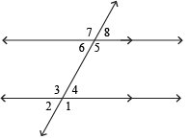

* Corresponding angles are congruent.
* Alternate interior angles are congruent.
* Same side interior angles are supplementary.
* Vertical angles are congruent.
* Alternate exterior angles are congruent.
* Same side exterior angles are supplementary.

**Proofs with Congruent Triangles**

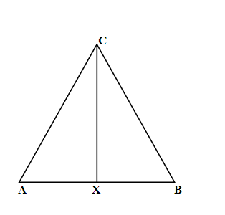1. Given: ∠CXA  ∠ CXB; X is the midpoint of 

Prove: 

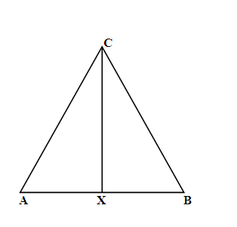2. Given: 

Prove: 

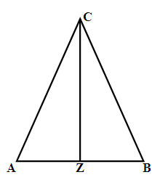Tell what follows directly from each of the given statements.

a. Z is the midpoint of  b.  is the perpendicular bisector of 

c.  is to  d.  bisects ∠ ACB

e.  bisects 

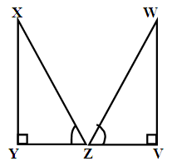 3. Fill in the reasons for this proof:

Given: ∠XZY ∠WZV; Z is the midpoint of ; ∠ Y & ∠ V are right ∠s

Prove: 

|  |  |
| --- | --- |
| Statements | Reasons |
| 1. ∠XZY ∠WZV |  |
| 2. Z is the midpoint of |  |
| 3. |  |
| 4. ∠ Y & ∠ V are right ∠s |  |
| 5. ∠Y  ∠ V |  |
| 6. |  |

4. Write a flow proof for the following.

Given: 

Prove: 

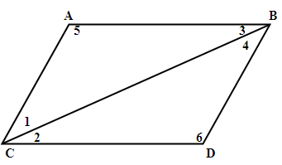

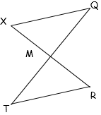**5.** Complete the following proof.

Given: ║

 bisects

Prove: 

**CPCTC**: Corresponding Parts of Congruent Triangles are Congruent

If two triangles are congruent, then their corresponding parts are congruent.

**Given: **

Congruent Angles: ____________ ____________ _____________

Congruent Sides: _____________ _____________ _____________

Which of the following is equivalent to****?

A. and  B.  and  C. and 

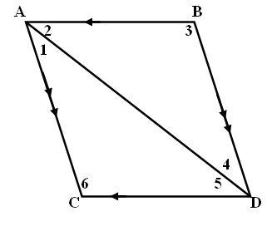6. Given: 

Prove: ∠ 3  ∠ 6

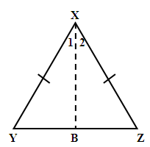7. Write a flow proof for the problem below.

Given:  bisects ∠ YXZ

Prove:

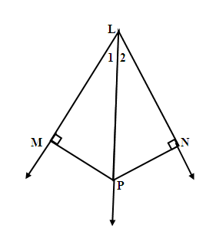

8. Write a proof for the following:

Given: bisects ∠ MLN; 

Prove: 

|  |  |
| --- | --- |
| **Statements** | **Reasons** |
| 1. |  |
| 2. |  |
| 3. |  |
| 4. |  |
| 5. |  |
| 6. |  |
| 7. |  |
| 8. |  |

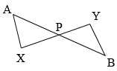9. Given:  , 

Prove:

**Congruent Right Triangles:**

**\*\*HL Theorem**:** If the hypotenuse and a leg of one right triangle are congruent to the hypotenuse and a   
 leg of another right triangle, then the triangles are congruent.

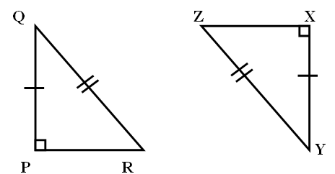

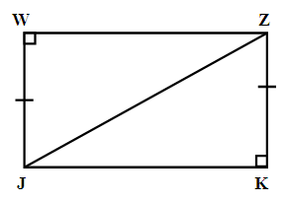10. Complete the following proof:

Given: ; ∠JWZ and ∠ZKJ

are right angles

Prove: $∆WJZ ≅∆KZJ$

|  |  |
| --- | --- |
| **Statements** | **Reasons** |
| a. ∠JWZ & ∠ZKJ are rt ∠s | a. |
| b. $∆WJZ and ∆KZJ are right ∆s$ | b. |
| c. | c. Reflexive POC |
| d. | d. Given |
| e. $∆WJZ ≅∆KZJ$ | e. |

**11.** Given: ,  FLOW PROOF

Prove: 

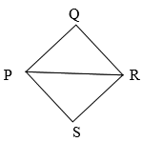

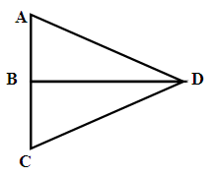12. Given: ; B is the midpoint of 

Prove: $∆ABD≅∆CBD$

Write a flow proof.

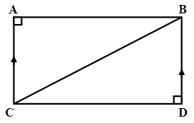

13. Given: ; 

Prove:

|  |  |
| --- | --- |
| **Statements** | **Reasons** |
|  |  |
|  |  |
|  |  |
|  |  |
|  |  |
|  |  |
|  |  |

14. Given: ;  is the perpendicular bisector of .

Prove: $∆CBD≅∆EBA$

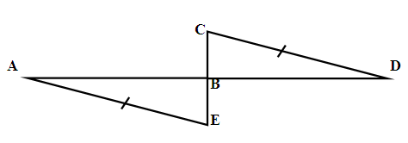

Write a flow proof.

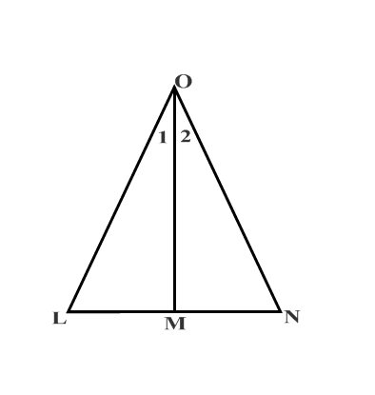

15. Given:

Prove:  ** Make a flow proof using triangle to the right

**Overlapping Triangles:**

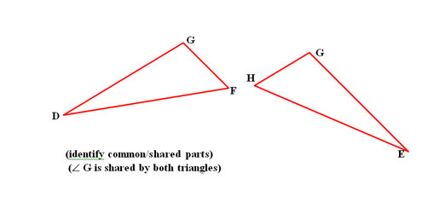

1.

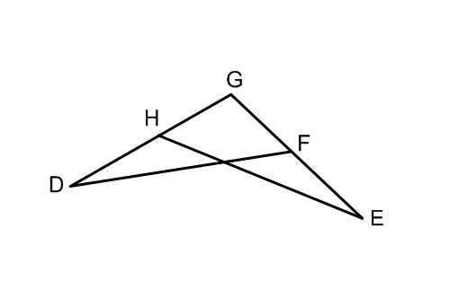

(separate the triangles) 🡪

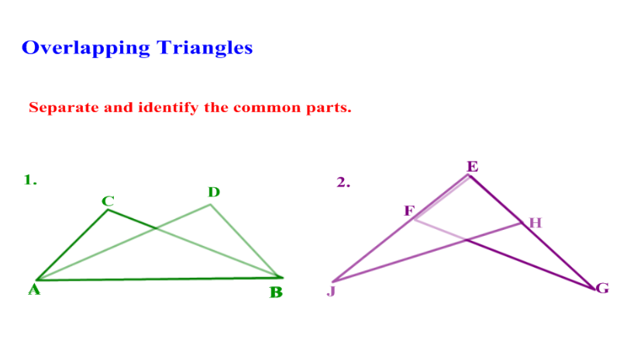

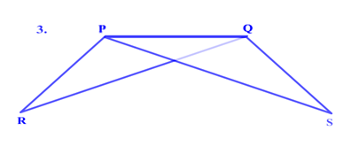

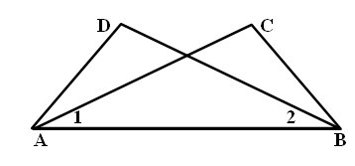

16. Given: ∠DAB  ∠ CBA , ∠ 1  ∠ 2

Prove: $∆ABD≅∆BAC$

|  |  |
| --- | --- |
| Statements | Reasons |
|  |  |
|  |  |
|  |  |
|  |  |

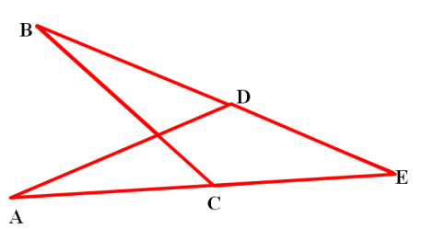17.

Given: 

Prove: 

Write a flow proof.