**Honors Math 2 S2016 Name:__________________________  
Unit 1 Review Date:________________ Block: ____**

**Multiple Choice: Select the correct answer. Write your answer on the line provided.**

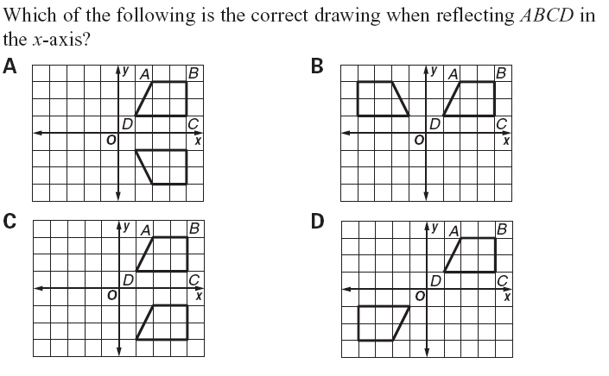1) 1) ________

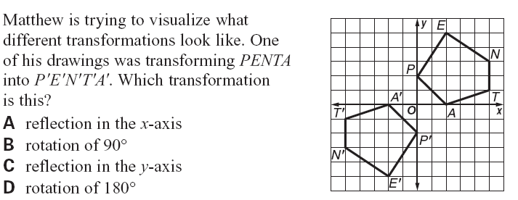

2) 2) ________

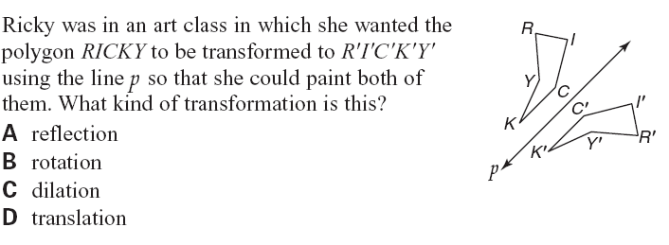

3) 3) ________

1)

4) 4) ________

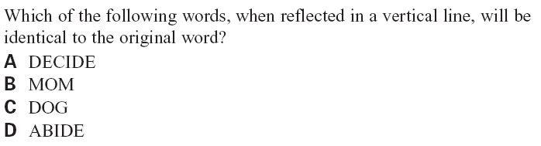

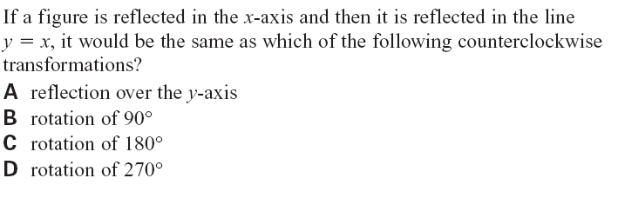5) 5) ________

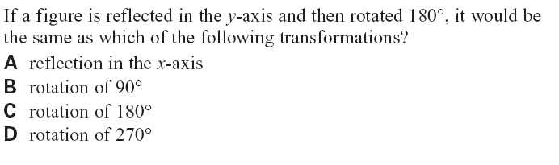

6) 6) ________

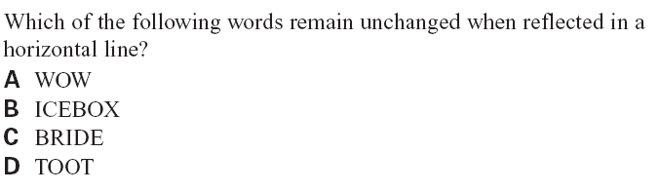

7) 7) ________

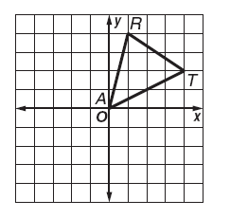**Use the figure for questions 8-10.**

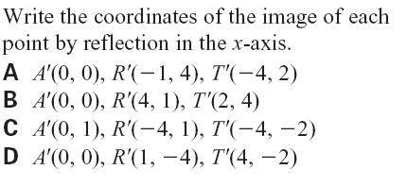8) 8) ________

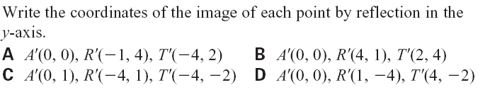9) 9) ________

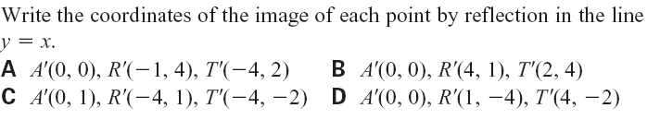10) 10) _______

11) 11) _______

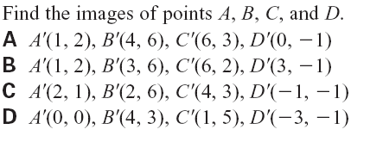

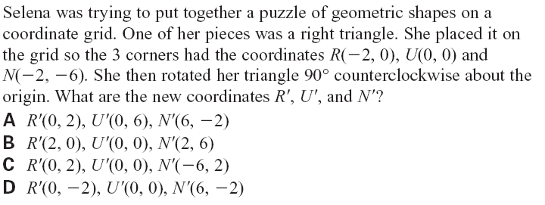  
12) 12) _______

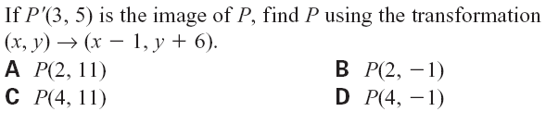13) 13) _______

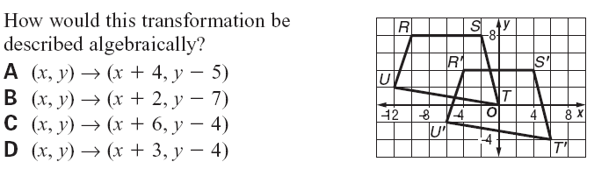

14) 14) _______

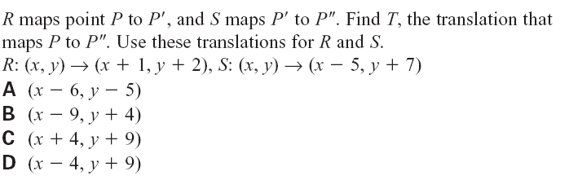

15) 15) _______

**Free Response: Answer the following questions. Show all work for full credit!**

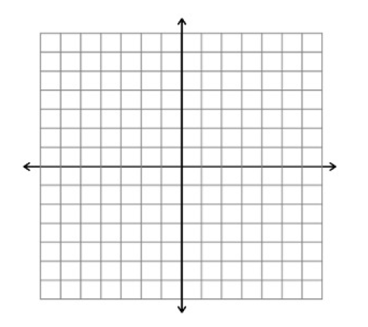16) Given A (1, 2), B (1, 4), and C (3, 4), find the image of  under a counterclockwise rotation of 90 degrees about the origin. Graph the pre-image and image. Label your pre-image and image points on the graph. Write the coordinates of your image points on the lines provided.

A’ __________

B’ __________

C’ __________

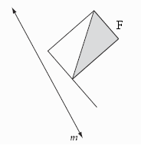17) Draw the image of figure F after a reflection over line *m*. Label the image and shade where appropriate. Write 2 observations comparing the pre-image to the image. You must write a complete sentence for each observation.

Observation #1 (one complete sentence): _____________________________________________

_____________________________________________

_____________________________________________

Observation #2 (one complete sentences):

_____________________________________________

_____________________________________________

_____________________________________________

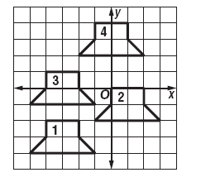18) Using the figure provided, write a translation rule for each of the following both algebraically and in vector notation.

Figure 1 to 2: _________________________________

Figure 4 to 3: _________________________________

19) Graph and label a triangle with vertices A (1, 5), B (4, 1), and C (5, 6). Apply a translation with the rule (x, y) -----> (x – 1, y – 2). Label and write the coordinates for triangle A’B’C’. Then reflect triangle A’B’C’ over the x-axis. Label and write the coordinates for triangle A’’B’’C’’.

A’’ __________

B’’ __________

C’’ __________

A’ __________

B’ __________

C’ __________

20) Draw a triangle DEFand line ***m*** intersecting the triangle. Draw the reflection image of triangle DEFover line ***m***. Label the image points.

21) Given   and , draw and label the triangles.

Find ** and ** 21)_________

1. 22
2. 11
3. 10
4. 25

22) Which pair of triangles is congruent by ASA? 22)_________

1. B.



C. D.

1. 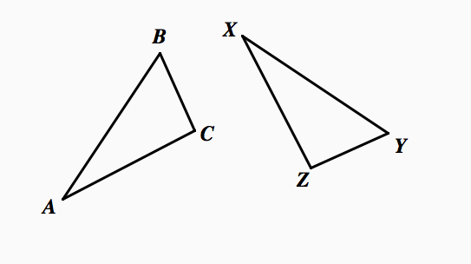In triangles to the right, $∆ABC ≅ ∆XYZ$.

Which two statements identify corresponding congruent parts for these triangles?

$\overline{AB} ≅\overline{XY} and ∠C ≅ ∠Y$

$\overline{AB} ≅\overline{YZ} and ∠C ≅ ∠X$

$\overline{BC} ≅\overline{XY} and ∠A ≅ ∠Y$

$\overline{BC} ≅\overline{YZ} and ∠A ≅ ∠X$

1. ΔBOY ≅ ΔDEA. ; $AD=60$; $AE=80$; $DE=40$. **Find *x***. 24)_________

25) ΔEXC ≅ ΔSTP. ; ; . **Find**  25)_________

26) Calculate the value for x, y, and z.

$m∠M=50$ x =

$m∠N=60$



$m∠O=70$ ________

y =

$m∠D=\left(2x-20\right)$



$m∠E=\left(\frac{1}{2}y+10\right)$ ________

z =

$m∠F=\left(10+z\right)$

 ________

1. Given the following image, explain how you know using rigid motions that map $∆ABC onto ∆EDG$.

Assuring that $∆ABC ≅ ∆EDG$.

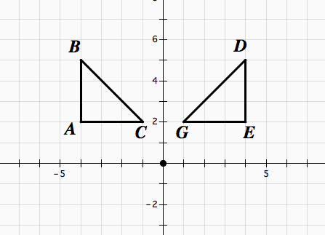

Write complete sentences: _____________________________________________

_____________________________________________

_____________________________________________

28) Find the value of x. 29) Find the value of x.



30) ∆PQR  ∆XYZ. List three pairs of congruent angles.

____________________ _____________________ ____________________

31) Suppose ∆ABC  ∆EFG. For each of the following, name the corresponding part.

: ______________ : ______________ : _______________



32) If AB is a midsegment, find:

x = ________

y = _________

z = _________

33)



S

R

T

10

RS = ___________

TR = ___________

D

F

E

13

14

16

34)

S

Q

V

15

2x + 4



N

M

P

10

x + 3

x = ___________

NP = ___________

QV = ____________

35) Assuming the two triangles are similar, find the tower's height from the given measurements below.

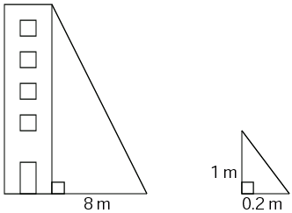

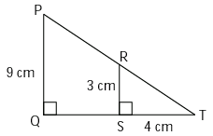36) Looking at the triangles in the figure on the right:

* 1. Are the two triangles similar?
  2. What is the length of *QT*?
  3. If *PT* is 15 cm, what is the length of *RT*?
  4. Is RS the midsegment of triangle TPQ? Why or why not?

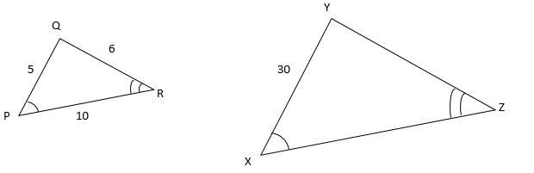37) ΔPQR is similar to ΔXYZ.

What is the perimeter of ΔXYZ?

38) A figure is reflected over the x-axis and then over the y-axis. Write the algebraic rule that would represent the transformation from the pre-image to the final image. Use the grid if you so choose.

Describe the single transformation from the pre-image

to the image: _________________________________

Write the Algebraic Rule for the Following: Use the coordinate plane if needed.

39. Rotate  __________________

40. Reflect over x-axis __________________

41. Reflect over  __________________

42. Rotate  __________________

43. Reflect over y-axis __________________

44. Reflect over  __________________

45. Rotate  __________________

**Solve each system of equations**

46. 8x + y = 17 47. 3x + 4y = 12

-4x – 3y = 9 5x + 3y = 1

48. y = x + 5 49. 2x + 3y = 12

x + y = 9 2x – y = 4