Honors Math 2 Name___________________________

Quadratics Test 2 Review Date____________________Block____

Solve the following quadratics by factoring.

|  |  |
| --- | --- |
| 1. | 2. |
| 3. | 4. |

Solve by completing the square. Solve using the quadratic formula.

|  |  |
| --- | --- |
| 5. | 6. |

|  |  |
| --- | --- |
| 7. Solve by Completing the Square. | 8. Solve by Quadratic Formula. |

For #’s 9 & 10 YOU MAY USE A CALCULATOR

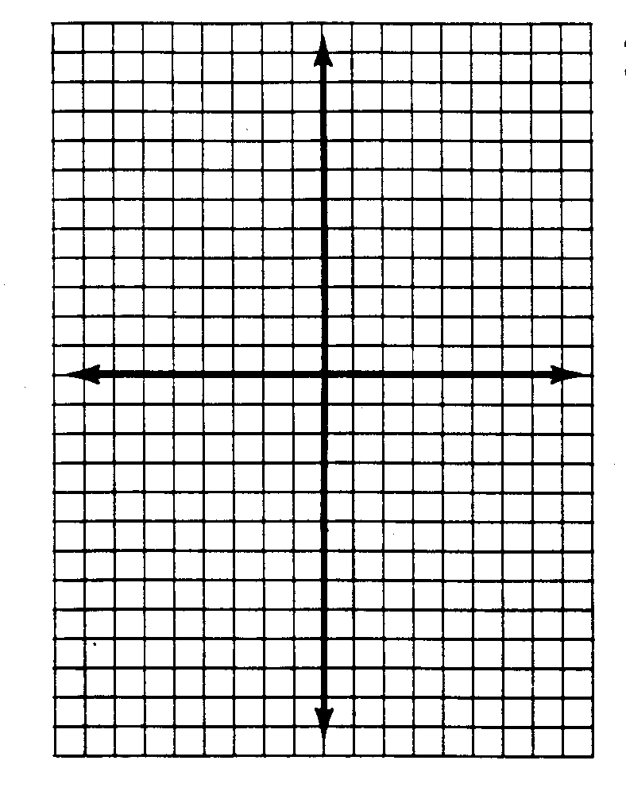9. Find the characteristics of each function and then use this information to produce the graph.

y = x2 + 6x – 5

Axis of Symmetry: ______

Vertex: _______________

x-intercepts:____________

y-intercepts: ___________

Domain: ______________

Range: _______________

Interval of Increasing: ______________

Interval of decreasing: ______________



10. y = -2 (x – 1)2 + 7

Axis of Symmetry: ______

Vertex: _______________

x-intercepts:____________

y-intercepts: ___________

Domain: ______________

Range: _______________

Interval of Increasing: ______________

Interval of decreasing: ______________

Given the function: y = x2 – 2x – 8 answer the following questions. (COMPLETE WITHOUT CALCULATOR)

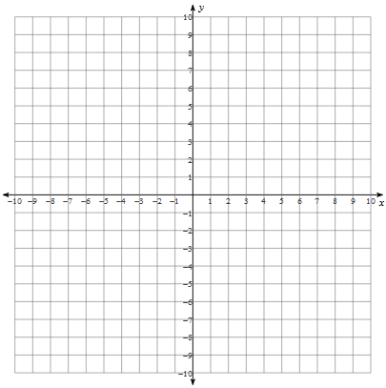11. Graph Find the following:

|  |
| --- |
| Convert to Vertex Form |
| Zeros |
| Y-Intercept |
| Axis of Symmetry |
| Vertex |
| Min or Max and @what value? |
| Domain |
| Range |
| Interval of Increasing |
| Interval of Decreasing |

|  |  |
| --- | --- |
| 12. Identify the transformations of each function from the parent function: y = x2. (COMPLETE WITHOUT CALCULATOR)   1. y = (x + 7)2 – 3 2. y = -4(x – 5)2 3. y = x2 + 6 | 13. Write an equation in vertex form, formed from y = x2  using the given transformations:   1. Shifted left 5 and up 3. 2. Reflected and then right 2. 3. Vertical stretch of 3, shifted left 2 and down 1. |