

**Proving Triangles Similar**

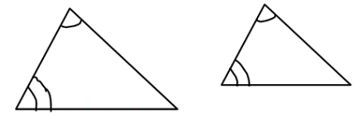**AA ~ Postulate:** If two angles of one triangle are **congruent** to two angles of another triangle, then the triangles are similar. (AA $\sim$)

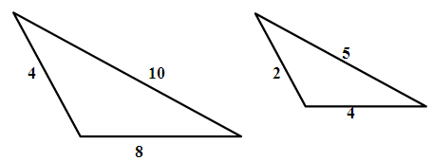**SSS ~ Theorem:** If the measures of the corresponding sides of two triangles are **proportional**, then the triangles are similar. (SSS $\sim$)

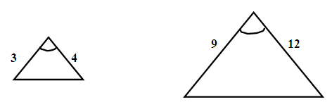**SAS ~ Theorem:** If the measures of two sides of a triangles are **proportional** to the measures of two corresponding sides of another triangle and the included angles are **congruent**, then the triangles are similar. (SAS)

1. If , write the proportionality statements for the side lengths.

Are the triangles below similar? If so, write a similarity statement and verify it.

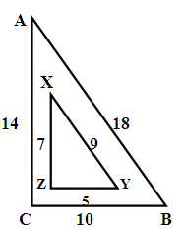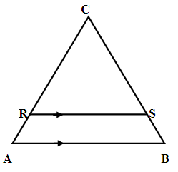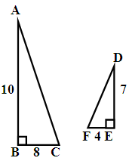

2. ___________________ 3. __________________ 4. ____________________