Rotations – Homework
Graph the image of the figure using the transformation given. Also, give the coordinates of the image, the algebraic rule, and the proper notation for the transformation.
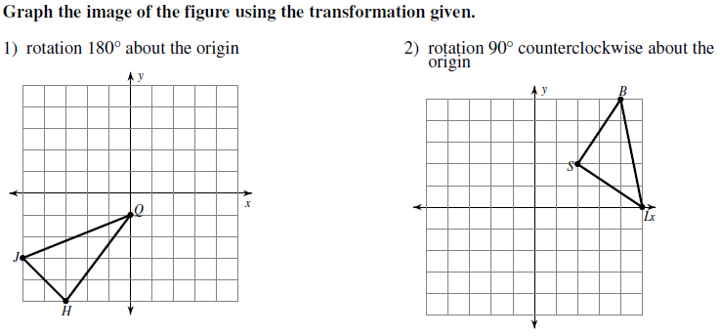
Coordinates:

Algebraic Rule:
Notation:
Coordinates:

Algebraic Rule:
Notation:
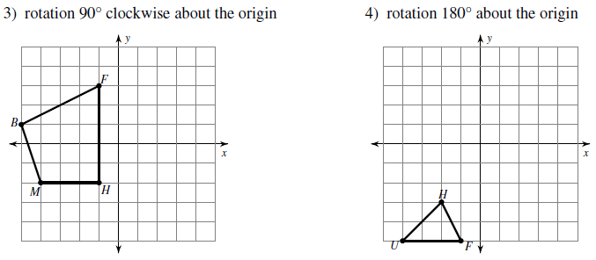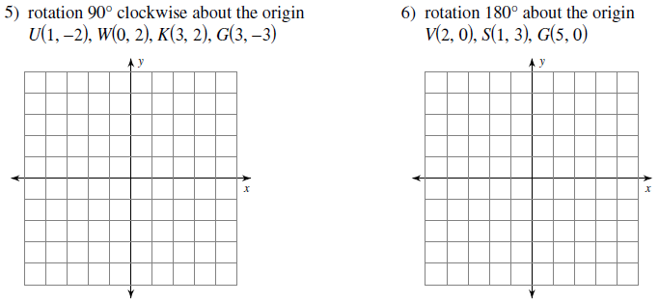
Coordinates:

Algebraic Rule:
Notation:
Coordinates:

Algebraic Rule:
Notation:
Coordinates:

Algebraic Rule:
Notation:
Coordinates:

Algebraic Rule:
Notation:
Identify the coordinates of the vertices for each figure after the given transformation. Also, give the algebraic rule for each transformation.
7) rotation 180° about the origin 8) rotation 180° about the origin
Z(-1, -5), K(-1, 0), C(1, 1), N(3, -2) L(1, 3), Z(5, 5), F(4, 2)
Vertices:
Algebraic Rule:
Vertices:
Algebraic Rule:

Write a specific description of each transformation AND give the algebraic rule.
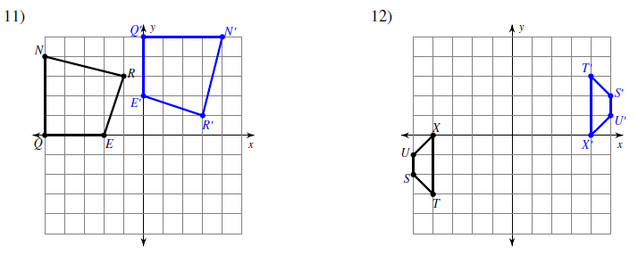
Description:

Algebraic Rule:
Description:

Algebraic Rule:
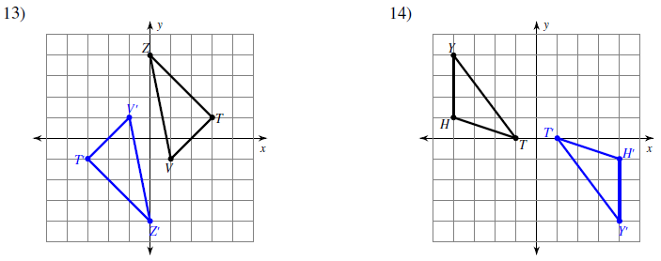
Description:

Algebraic Rule:
Description:

Algebraic Rule:

