|  |
| --- |
| **Day 6: Quiz Review** |

**Graph the image of the figure using the transformation given AND write the algebraic rule.**

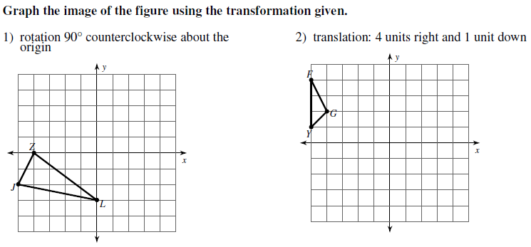

Algebraic Rule:

Notation:

Algebraic Rule:

Notation:

Algebraic Rule:

Notation:

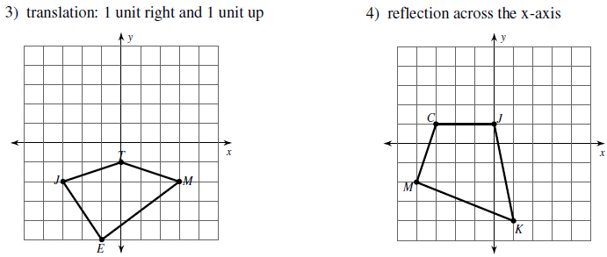

Algebraic Rule:

Notation:

**Write a verbal description and a motion rule, as requested, to describe each transformation.**

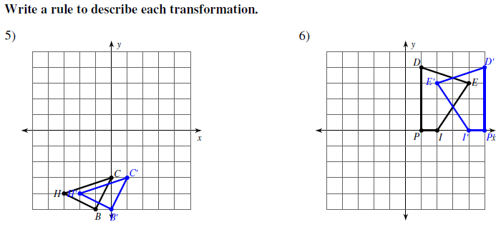

Description:

Algebraic Rule:

Description:

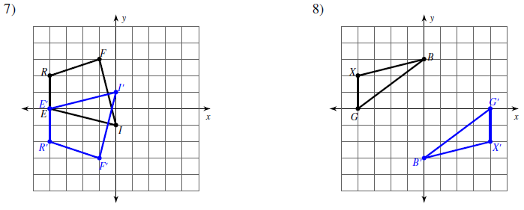

Description:

Algebraic Rule:

Description:

Algebraic Rule:

**Graph the image of the figure using the transformation given and write the algebraic rule.**

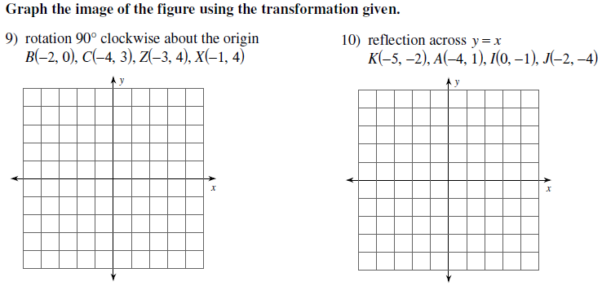

Algebraic Rule:

Notation:

Algebraic Rule:

Notation:

**11. Use with A(2,-2), B(3,1), and C(1,2) 12.** If $∆D'E'F'$ has coordinates D’ (-3, 1),

is reflected over y = -x and moved E’(4, 2) and F’(2, -3) was the result of   
 up 2 a translation with rule (x – 2, y + 3),

what are the coordinates for the preimage,

$∆DEF$?

D _______ E _______ F ________

Algebraic Rule: _________________