Name ___________________________

Unit 2 Exam Review - Quadratic Equations

Multiple Choice -Identify the choice that best completes the statement or answers the question. Make sure to show ALL work to receive full credit.

1. When solving the equation by completing the square, which equation is a step in the process?
a.
b.
c.
d.

2. The solutions to the equation 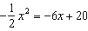 are
a.
b.
c.
d.

3. When factored completely, is
a.
b.
c.
d.

4. In the function , the minimum value occurs when x is
a.
b. | 2
c.
d. | 4

5. The zeros of the function are
a. | 3 and
b. | 3 and 1
c. | and 1
d. | and

Short Answer- Show ALL work to receive full credit.

6. Rewrite each sum or difference in standard polynomial form.

a.

b.

7. Consider the quadratic function .

a. Rewrite the function rule in vertex form.

b. Determine the coordinates of the maximum or minimum point of the graph of this function.

c. Solve the equation using the quadratic formula.

8. Consider the quadratic function . Complete each task by algebraic reasoning alone. Show all of your work to support your answers.

a. Rewrite the function rule in vertex form.

b. Does the graph of this function have a maximum or a minimum? Determine the coordinates of the
maximum or minimum point of the graph of this function.

c. What are the coordinates of the x-intercepts of the graph of this function?

d. What are the coordinates of the y-intercept of this function?
- State all transformations from the graph of

- 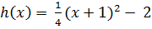

- Graph each of the following functions and state the transformation in each case.

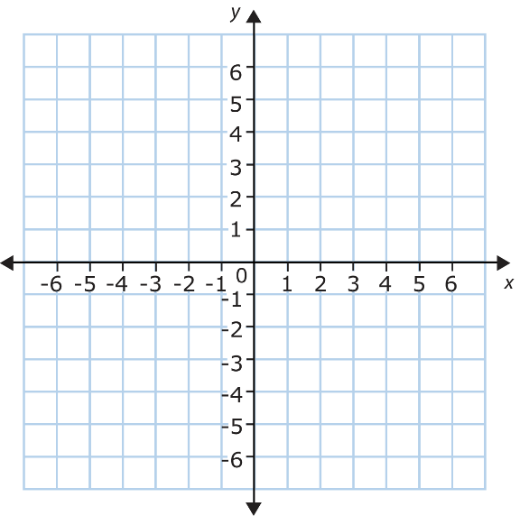
c.
- Write an equation for each function formed from the identity function using the given transformations.

- Reflected, stretch factor (narrows) of 3, shifted 5 units to the right, and shifted 7 units down.

- Compression factor (widens) of and shifted 4 units to the left.

- Reflection over the x-axis and shifted 3 units up

Factor each polynomial completely. Write “prime” if it is not factorable.
12. 4x³ – 12x² 13. x² – 3x – 10

14. x² – 25 15. x² + 5x + 6

16. 2x² – 9x + 4 17. x² + 2x– 11

18. Solve each quadratic equation by factoring or using the quadratic formula.

a. x + 8x + 15 = 0 |  | b. x - 4x = x - 3

19. Solve by completing the square.

Find the characteristics parts of each function. Use this information to produce the graph.

20. y = -x² – 6x – 4 21. y = (x + 3)² – 1
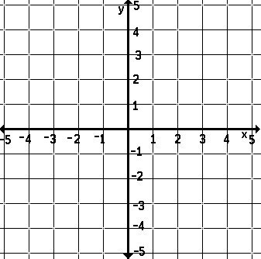

AOS: _______ Vertex: _______ AOS: _______ Vertex: _____

X-Intercept(s): _____________ X-Intercept(s): _____________

Y- Intercept: ______________ Y- Intercept: ______________

Domain: ________________ Domain: ________________
Range: __________________ Range: __________________
Interval of Increasing: __________ Interval of Increasing:___________
Interval of Decreasing: __________ Interval of Decreasing: _____________
Use the discriminant to determine the number and types of solutions for each quadratic equation. You do NOT have
to find the exact solutions.

22. 5x² – 4x + 3 = 0 23. 2x² – 3x – 4 = 0

24. x² + 8x + 16 = 0 25. 6x² – 7x = 3

Determine if each of the following statements are always, sometimes or never true.

26. The product of two rational numbers is rational.

27. The sum of two irrational numbers is irrational.

28. The product of two irrational numbers is irrational.

29. The sum of two rational numbers is rational.

