**Day 8: Compositions**

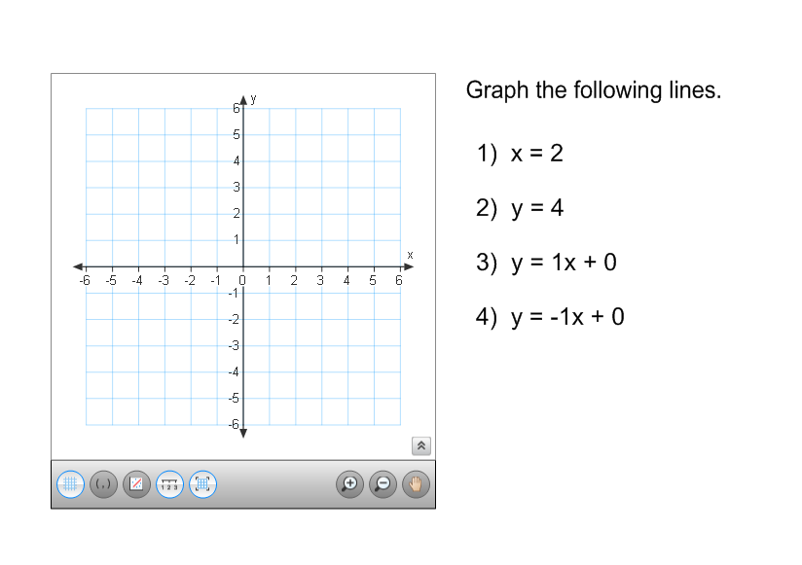**Warm-Up**: Given triangle GHI with G(-2, 1), H(3, 4), and I(1, 5), find the points of the image under the following transformations and write the Algebraic Rule.

1. Translate right 2, down 3
2. Reflect over the x-axis

1. Rotate 90 degrees, counter-clockwise

1. Dilate with a scale factor of 3

**Compositions of Transformations**

**Investigation: Reflections over two lines**

1. a. Lines l and k below are a pair of parallel lines. Label the vertices of the triangle A, B, C, etc.



k

l

b. Use a Mira to reflect ABC over line l. Label the corresponding vertices of the image A’, B’, and C’.

c. Use a Mira to reflect A’B’C’ over line k. Label the corresponding vertices of the image A’’, B’’, and C’’.

d. Draw the segment connecting the vertices A and A’’. Draw the segment connecting B and B’’. Draw the segment connecting C and C’’. Compare the lengths of each segment.

e. Write a statement comparing the size of the figures and positions relative to the lines of reflection.

f. What single transformation will map triangle ABC to triangle A”B”C”? Be specific in your description.   
Explain how you know.

**Investigation: Reflections over Two Lines (continued)**

1. a. Lines l and k intersect at point P. Label the vertices of the triangle A, B, C, etc.

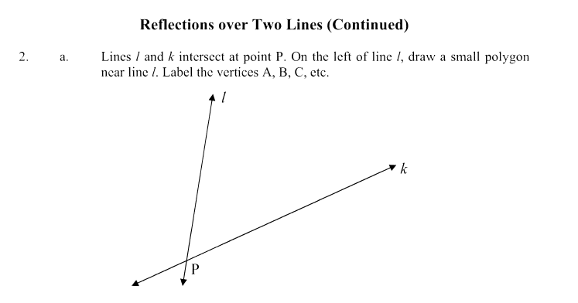

b. Use a Mira to reflect ABC over line l. Label the corresponding vertices of the image A’, B’, and C’.

c. Use a Mira to reflect A’B’C’ over line k. Label the corresponding vertices of the image A’’, B’’, and C’’.

d. Draw segments connecting A to P, and A” to P. Compare the measure of the angle you just drew to the measure of the acute angle formed by lines *l* and *k*.

e. Write a statement comparing the size of the figures and positions relative to the lines of reflection.

f. What single transformation will map triangle ABC to triangle A”B”C”? Be specific in your description. Explain how you know.

**Checkpoint and Summary**

A ____________________ is a sequence of _________________________________________.

Two reflections across _____________ lines is the same as a __________________________.

A _________________ is the same as a double reflection around ____________________ lines.

The point of rotation is the ______________ of the ________ _____________________ __________.

**Compositions**

Translation R maps P to P’ and translation S maps P’ into P”. Find T, the translation that maps **P directly to P”.**

1. R: (x, y) (x – 3, y + 2) 2. R: (x, y)  (x, y + 1)

S: (x, y)  (x + 1, y + 7) S: (x, y)  (x + 4, y - 1)

T: (x, y)  (?, ?) T: (x, y)  (?, ?)

3. R: (x, y)  (x + 1, y - 3)

S: (x, y)  (x - 4, y - 3)

T: (x, y)  (?, ?)

**More Practice**

4. The translation T is followed by the translation T.   
 Write this as a single translation.

5. The rotation ${\text{R}}_{O, 90°}$ is followed by the rotation ${\text{R}}_{O, -270°}$. Write this as a single rotation.

**Glide Reflection:** a translation (glide) followed by a reflection

A glide reflection changes orientation. Why?

**Theorem:** there are only 4 isometries

* Reflection
* Translation
* Rotation
* Glide reflection

**Glide Reflection:**

6. A glide reflection has the glide (translation) T: (x, y)  (x – 2, y – 2).

Its line of reflection is y = x

a.) Find the image P’ of P(3, 5) under T.

b.) Find the image P” of P’ under the reflection in line y = x.

c.) Under the glide reflection, (x, y) is mapped into (?, ?) and then into (?, ?)

A glide reflection has translation T and reflection in the given line.

a.) Find the image P’ of P under T

b.) Find the image P” of P’ under reflection in the line

c.) Under the glide reflection, (x, y) is mapped to (?, ?) and then to (?, ?)

7. T: (x, y) (x - 4, y + 4) 8. T: (x, y)  (x, y - 2)

 Reflection line is: y = x Reflection line is: y-axis

 P (4, 0) P (-1, 5)