**Midterm Review**

1. **Given a pre-image of a triangle with vertices $A\left(-1, 4\right), B\left(0,-3\right), C\left(2-6\right)$ is transformed. Find the Image after the following transformation;**

Honors Math 2 S2017 Name: __________________________

1. **Translated 4 up and 2 left. b. Translated 1 down and 3 right.**

$A'\left(____,_____\right)$**, B’ $\left(____,_____\right)$, $C'\left(____,_____\right)$ $A'\left(____,_____\right)$, B’ $\left(____,_____\right)$, $C'\left(____,_____\right)$**

1. **Dilated by a factor of 2. d. Dilated by a scale factor of $\frac{1}{2}.$**

$A'\left(____,_____\right)$**, B’ $\left(____,_____\right)$, $C'\left(____,_____\right)$ $A'\left(____,_____\right)$, B’ $\left(____,_____\right)$, $C'\left(____,_____\right)$**

1. **Reflected over the $x$-axis. f. Reflected over the $y-$ axis.**

$A'\left(____,_____\right)$**, B’ $\left(____,_____\right)$, $C'\left(____,_____\right)$ $A'\left(____,_____\right)$, B’ $\left(____,_____\right)$, $C'\left(____,_____\right)$**

**g. Reflected over the line $y=x$. h. Reflected over the line $y=-x$.**

$A'\left(____,_____\right)$**, B’ $\left(____,_____\right)$, $C'\left(____,_____\right)$ $A'\left(____,_____\right)$, B’ $\left(____,_____\right)$, $C'\left(____,_____\right)$**

**i. Rotated $180°$ counterclockwise. J. $Rotated 90° counterclockwise.$**

$A'\left(____,_____\right)$**, B’ $\left(____,_____\right)$, $C'\left(____,_____\right)$ $A'\left(____,_____\right)$, B’ $\left(____,_____\right)$, $C'\left(____,_____\right)$**

1. 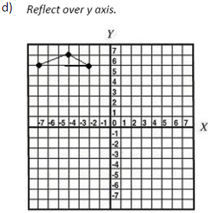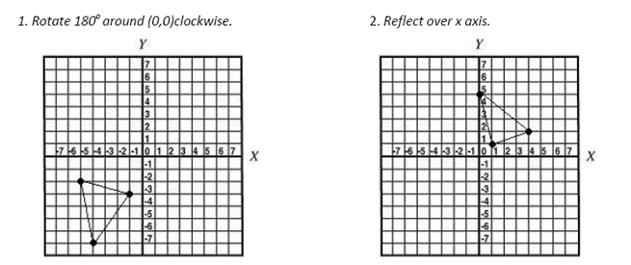**For problems 2-4, a) write the coordinates of the pre-image points, b) draw the transformation, c) write the coordinates of the image points, and d) write the rule (x, y) 🡪 (???, ???) associated with the transformation**

b)

a)

c)

1. 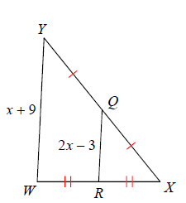**Solve for $x$ and $y.$**

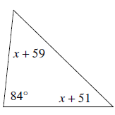

$$y°$$

1. **b. c.**

$(x^{2}-3x)°$ $40°$

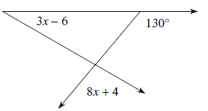

**d. e. $\frac{4}{12}=\frac{x+2}{2x+5}$ f. $\frac{x+1}{6}=\frac{x-1}{x}$**

**g. $∆ABC\sim ∆ADE$ h. U is between T and B, TU = 4x – 1, UB = 2x – 1, TB = 5x**

$$15$$

$$12$$

$$4$$

$$y$$

$$x$$

$$C$$

$$B$$

$$D$$

$$E$$

$$A$$

$$10$$

**i. ∠A and ∠B are supplementary. Find the value of x, m∠A, and m∠B if $m∠A=x+16, m∠B=2x-16$.**

1. **∠C and ∠D are complementary. Find the value of y, m∠C, and m∠D if $m∠C=y-8, m∠D=3y+2$.**
2. **State if the triangles are congruent. If they are state how you know.**
3. **ΔABC ≅ Δ______ b. ΔADC ≅ Δ________ c. ΔABE ≅ Δ_________**

**by____________ by__________ by_________**

A

B

E

C

D

A

B

D

C

C

A

D

B

**d. ΔABE ≅ Δ______ e. ΔABC ≅ Δ________**

A

B

D

E

C

**by____________ by__________**

T

S

R

B

C

A

1. **If $∆ABC\sim ∆XYZ$, $AB=x+6, XY=x, CA=4,$ and $XZ=1,$ find $AB.$**
2. **State if the triangles are similar. If they are state how you know.**

**a. ΔABC ~ Δ______ b. ΔGHF ~ Δ________ c. ΔVUT ~ Δ__________**

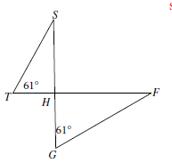 **by____________ by__________ by_________**

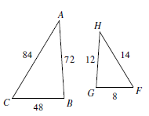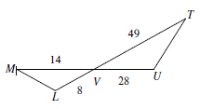

**7. Solve each of the following equations without the use of a calculator. You must use each of the following methods at least one time: 1) Simple Factoring - then solving, 2) The Quadratic Formula, 3) Completing the Square, Taking Square Roots.**

**a. x2 + 5x = 0 b. 3x – 5x2 = 0 c. 4x2 – 64 = 0**

**d. x2 + 6x = 7 e. 2x2 + 8x + 5= 0 f. **

**8. Simplify**

a.  b. 

c.  d. 

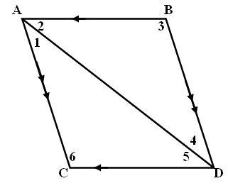9. Complete the following proof:

Given: 

Prove: 

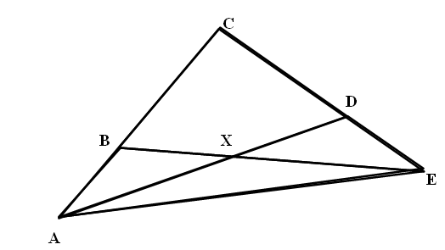10. Given:  , 

Prove: 

Short answer.

11. Identify the transformations that always preserve angle measure.

12. Identify the transformations that always result in an isometry.

13. Identify the transformations that always produce corresponding sides that are parallel.

14. Identify the transformations that, when the corresponding vertices of a pre-image and image are connected with lines, those lines will intersect at a single point.

15. Factor Completely.

a.  b.  c. 

e.  f.  d. 