**Math 2**

**Transformations**

**Congruent figures** _______________________________________________________________ .

When two figures are congruent, you can move one so that ____________________________

_______________________________________________.

**Transformation** of a geometric figure: change in its ______________, ____________, or ________.



**Preimage** – ________________ figure

Notation: __________

**Image** – _______ or _______________ figure

Notation: __________

**Isometry** – transformation in which preimage and image are the ____________ _____________ and

_______________ (also called: ______________________________________________)



Examples:

___________________ , _____________________ , and __________________

**Translation** – an isometry that maps all points the ___________ ____________________ and the

___________ ___________________.

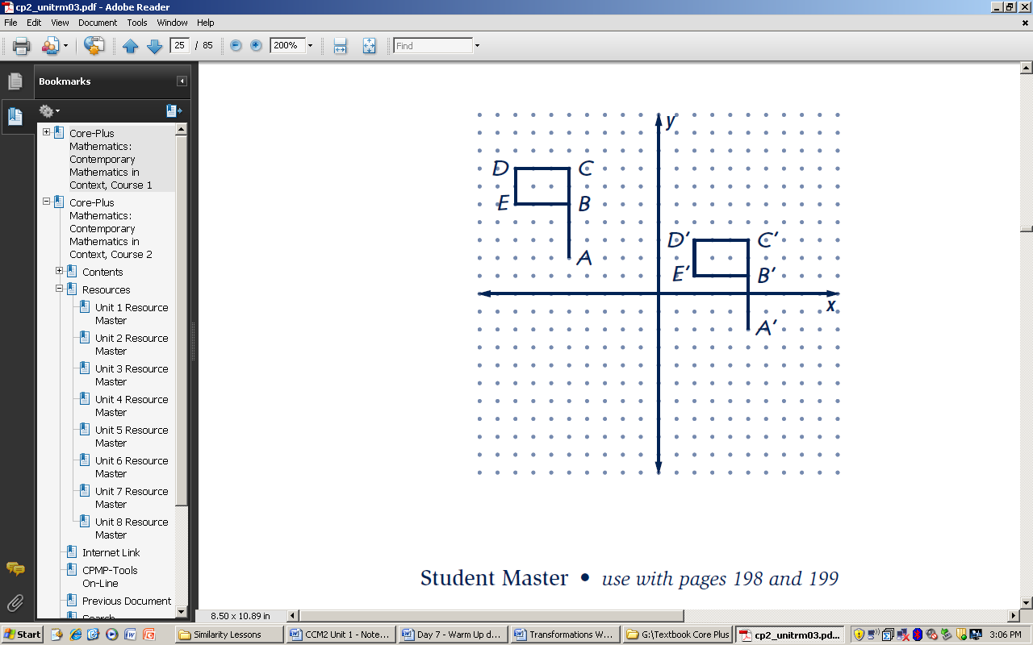**Two ways to describe a transformation** (using example shown right):

**Always **be specific** when completing **any** type of description!!

1. **Words:** Translation to the right 10 units and down 4 units.
2. **Algebraic** **rule** (motion rule): T: (x, y) -> (x + 10, y – 4)

**Activity: Dot Paper Translations**

1. Use the dots to help you draw the image of the first figure so that A maps to A’.
2. Use the dots to help you draw the image of the second figure so that B maps to B’.
3. Use the dots to help you draw the image of the third figure so that C maps to C’.
4. Complete each of the following translation rules using your mappings from 1 – 3 above.
5. For A, the translation rule is: T:(x, y) → ( _______, _______ )
6. For B, the translation rule is: T:(x, y) → ( _______, _______ )
7. For C, the translation rule is: T:(x, y) → ( _______, _______ )

**. . . . . . . . . . . . . .**

**. . . . . . . . . . . . . .**

B’

**. . . . . . . . . . . . . .**

**. . . . . . . . . . . . . .**

**. . . . . . . . . . . . . .**

B

A

**. . . . . . . . . . . . . .**

**. . . . . . . . . . . . . .**

**. . . . . . . . . . . . . .**

**. . . . . . . . . . . . . .**

C

A’

**. . . . . . . . . . . . . .**

**. . . . . . . . . . . . . .**

**. . . . . . . . . . . . . .**

C’

**. . . . . . . . . . . . . .**

**. . . . . . . . . . . . . .**

**. . . . . . . . . . . . . .**

**Checkpoint:** ΔGEO has coordinates G(-2, 5), E(-4, 1) O(0, -2). A translation maps G to G’ (3, 1).

1. Find the coordinates of: a) E’ ( _____, _____) b) O’ ( _____, _____)
2. The translation rule is T: (x, y) → ( _______, _______ )

3. Specifically describe the transformation: ________________________________________

