1. Given$y=x^{2}-x+8$, answer every question on this page.
HONORS MATH 2 Everything on Quadratics V1
Name_________________________________________
Date__________________Period__________________
Axis of Symmetry | Vertex
Zeroes by factoring | Zeroes by Calculator
Zeroes by Completing the Square | Minimum or Max and @ what value?
Domain Range | Interval  Increasing? Decreasing?
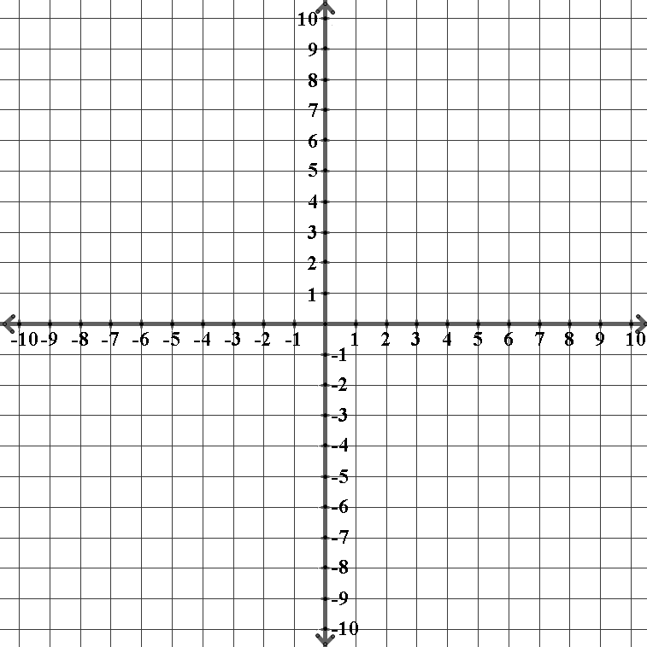
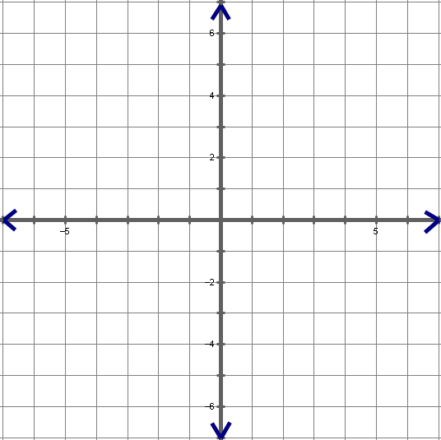
Graph

Zeros / Roots / Solutions / x-intercepts by Quadratic Formula

Discriminant_______ Type of Roots____________
©Rasey2017

2. Given$y=-x^{2}+x+6$, answer every question on this page.
Axis of Symmetry | Vertex
Zeroes by factoring | Zeroes by Calculator
Zeroes by Completing the Square | Minimum or Max and @ what value?
Domain Range | Interval  Increasing? Decreasing?
Graph

Zeros / Roots / Solutions / x-intercepts by Quadratic Formula

Discriminant_______ Type of Roots____________
©Rasey2017

3. Given$y={2x}^{2}-12x+10$, answer every question on this page.
Axis of Symmetry | Vertex
Zeroes by factoring | Zeroes by Calculator
Zeroes by Completing the Square | Minimum or Max and @ what value?
Domain Range | Interval  Increasing? Decreasing?
Graph

Zeros / Roots / Solutions / x-intercepts by Quadratic Formula

Discriminant_______ Type of Roots____________
©Rasey2017

4. Given$y=-3x^{2}+3x+6$, answer every question on this page.
Axis of Symmetry | Vertex
Zeroes by factoring | Zeroes by Calculator
Zeroes by Completing the Square | Minimum or Max and @ what value?
Domain Range | Interval  Increasing? Decreasing?
Graph

Zeros / Roots / Solutions / x-intercepts by Quadratic Formula

Discriminant_______ Type of Roots____________
©Rasey2017

5. Given$y=8-2x^{2}$, answer every question on this page.
Axis of Symmetry | Vertex
Zeroes by factoring | Zeroes by Calculator
Zeroes by Completing the Square | Minimum or Max and @ what value?
Domain Range | Interval  Increasing? Decreasing?
Graph

Zeros / Roots / Solutions / x-intercepts by Quadratic Formula

Discriminant_______ Type of Roots____________
©Rasey2017

6. Given$y=x^{2}+5x+6$, answer every question on this page.
Axis of Symmetry | Vertex
Zeroes by factoring | Zeroes by Calculator
Zeroes by Completing the Square | Minimum or Max and @ what value?
Domain Range | Interval  Increasing? Decreasing?
Graph

Zeros / Roots / Solutions / x-intercepts by Quadratic Formula

Discriminant_______ Type of Roots____________
©Rasey2017

7. Given$y=x^{2}-8x$, answer every question on this page.
Axis of Symmetry | Vertex
Zeroes by factoring | Zeroes by Calculator
Zeroes by Completing the Square | Minimum or Max and @ what value?
Domain Range | Interval  Increasing? Decreasing?
Graph

Zeros / Roots / Solutions / x-intercepts by Quadratic Formula

Discriminant_______ Type of Roots____________
©Rasey2017

8. Given $y=-x^{2}+4x+5$, answer every question on this page.
Axis of Symmetry | Vertex
Zeroes by factoring | Zeroes by Calculator
Zeroes by Completing the Square | Minimum or Max and @ what value?
Domain Range | Interval  Increasing? Decreasing?
Graph

Zeros / Roots / Solutions / x-intercepts by Quadratic Formula

Discriminant_______ Type of Roots____________
©Rasey2017

