**Dilations – Discovery Activity**

**Alice in Wonderland**

In the story, Alice’s Adventures in Wonderland, Alice changes size many times during her adventures. The changes occur when she drinks a potion or eats a cake. Problems occur throughout her adventures because Alice does not know when she will grow larger or smaller.

**Part 1**

As Alice goes through her adventure, she encounters the following potions and cakes:

Red potion – shrink by  Chocolate cake – grow by 12 times

Blue potion – shrink by  Red velvet cake – grow by 18 times

Green potion – shrink by  Carrot cake – grow by 9 times

Yellow potion – shrink by  Lemon cake – grow by 10 times

Find Alice’s height after she drinks each potion or eats each bite of cake. **If everything goes correctly, Alice will return to her normal height by the end.**

|  |  |  |  |
| --- | --- | --- | --- |
| **Starting Height** | **Alice Eats or Drinks** | **Scale factor from above** | **New Height** |
| **54 inches** | Red potion |  | 6 inches |
| 6 inches | Chocolate cake |  |  |
|  | Yellow potion |  |  |
|  | Carrot cake |  |  |
|  | Blue potion |  |  |
|  | Lemon cake |  |  |
|  | Green potion |  |  |
|  | Red velvet cake |  | **54 inches** |

**Part 2**

A) The graph below shows Alice at her normal height.

B) Place a ruler so that it goes through the origin and point A. Plot point A’ such that it is twice as far from the origin as point A. Do the same with all of the other points. Connect the points to show Alice after she has grown. (Hint: measure with centimeters so that you can use decimal values.)

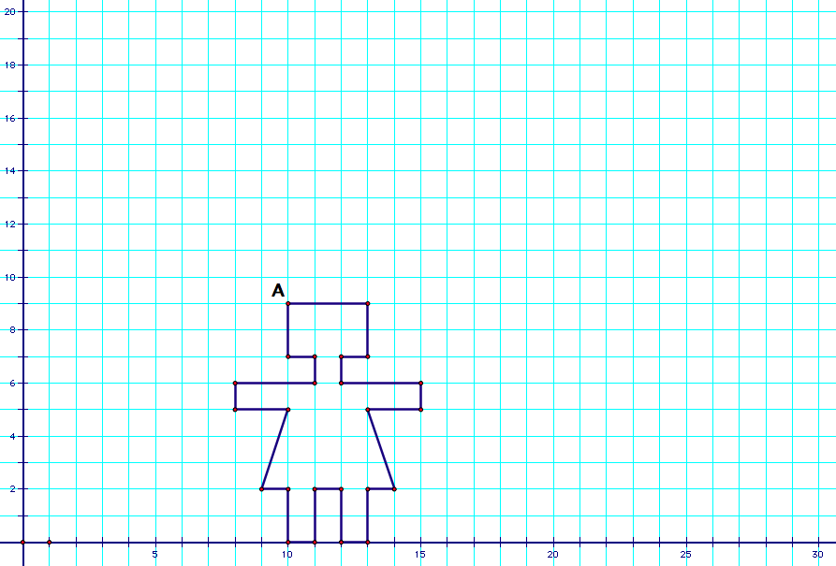

C) Label some of the corresponding preimage and image coordinate pairs. Compare their values to complete the questions below.

1. How many times larger is the new Alice? ______________________
2. How much farther away from the origin is the new Alice? _____________________
3. What are the coordinates for point A? ___________ Point A’? ___________
4. What arithmetic operation do you think happened to the coordinates of A?
5. Write your conclusion as an Algebraic Rule 

D) What arithmetic operation on the coordinates do you think would shrink Alice in half?

E) Write your conclusion as an Algebraic rule.

F) If Alice shrinks in half, how far away from the origin will her image be from her preimage?

G) On the grid above, graph the image of Alice if she is shrunk by a scale factor of ½ from her original height.

**Checkpoint:**

A dilation stretches or shrinks the original figure.

The description of a dilation should include the ___________ _______________, the ________________ of the dilation, and whether the dilation is an ___________________________ or a _______________________.

The amount by which the image grows or shrinks is called the "______________ ________________."

The _____________ of dilation is a fixed point in the plane about which all points are expanded or contracted.

A dilation is

* An enlargement of the pre-image if the ________ __________ is ______________________________.
* A reduction of the pre-image if the ________ __________ is _________________________________.

If the scale factor is 1, then the pre-image and image are _______________________.

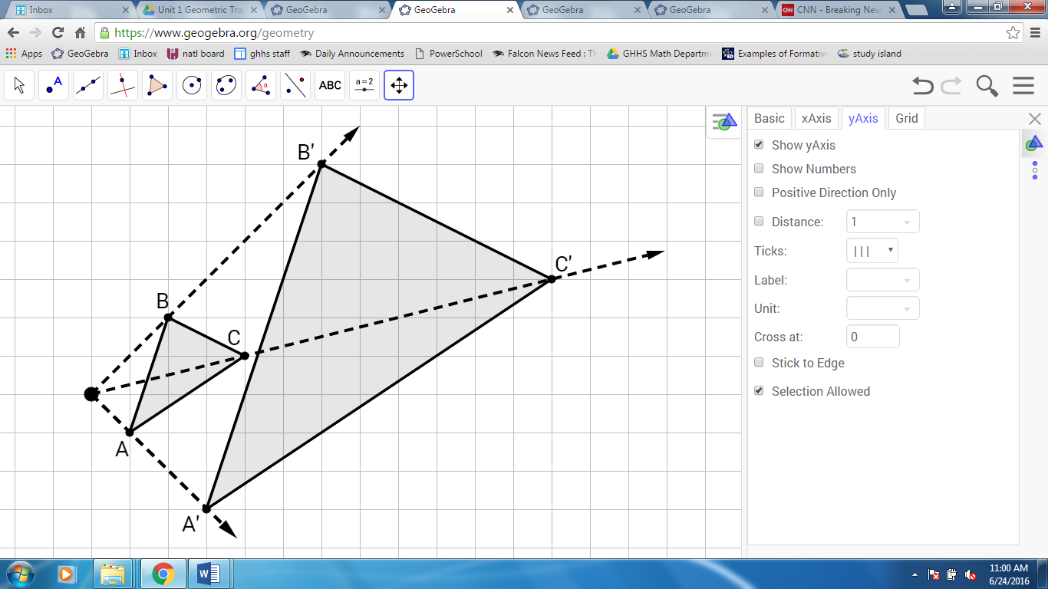Notation for Dilations: D ____, _____

Algebraic Rule: (x, y) → (ax, ay)   
 if a > 1 then the dilation is __ _________________

if 0 < a < 1 then the dilation is __ ______________

The distance between the center of a dilation and any point on the image is equal to the __________ __________ multiplied by the distance between the dilation center and the corresponding point on the image.

Circle the appropriate choice for the following characteristic/property:

A dilation is SOMETIMES / ALWAYS / NEVER an ‘Isometry’.

**Practice: Dilations with Coordinates**

For each problem, graph the image points, and describe the transformation that occurred. Specify if the transformation is an enlargement or reduction and by what scale factor. Then, examine the coordinates to create an Algebraic Rule.

|  |  |
| --- | --- |
| 1. The coordinates of ABC are   A(2, -1), B(3, 2) and C(-3, 1). The coordinates of A’B’C’ are A’(1, -1/2),  B’(3/2, 1), and C’(-3/2, 1/2).  Transformation:  Algebraic Rule: |  |
| 1. The coordinates of ABC are   A(2, -1), B(3, 2) and C(-3, 1). The coordinates of A’B’C’ are A’(4, -2),  B’(6, 4), and C’(-6, 2).  Transformation:  Algebraic Rule: |  |
| 1. The coordinates of ABC are A(2, -1),   B(3, 2) and C(-3, 1). The coordinates of A’B’C’ are A’(3, -3/2), B’(9/2, 3), and  C’(-9/2, 3/2).  Transformation:  Algebraic Rule: |  |