Day 4 Homework
Graph the image using the transformation given, write the proper notation, and give the algebraic rule as requested.
- reflection across the y-axis 2) reflection across y = x
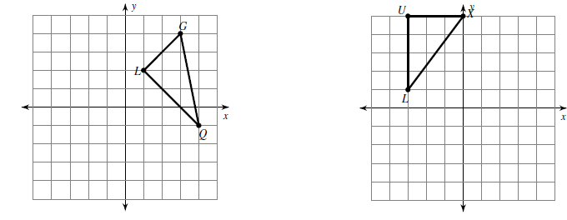
Notation:

Algebraic Rule:
Notation:

Algebraic Rule:
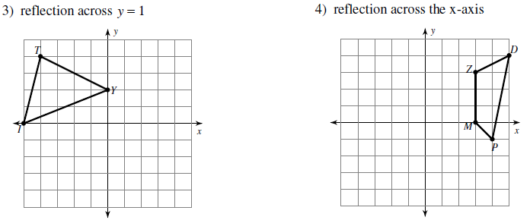
Notation:

Algebraic Rule:
Notation:

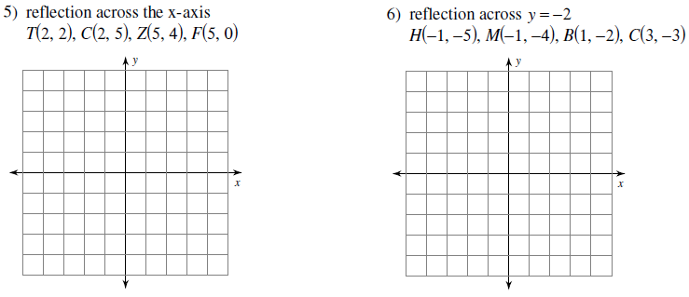
Algebraic Rule:

Find the coordinates of the vertices of each figure after the given transformation and give the algebraic rule, as requested. (Hint: Using graph paper may help on these!)
7) Reflection across the x-axis 8) Reflection across y = -x
K(1, -1), N(4, 0), Q(4, -4) R(-3, -5), N(-4, 0), V(-2, -1), E(0, -4)
Algebraic Rule:
Algebraic Rule:

9) Reflection across x = 3 10) Reflection across x = -1
F(2, 2), W(2, 5), K(3, 2) V(-3, -1), Z(-3, 2), G(-1, 3), M(1, 1)

Write a specific description of each transformation and give the algebraic rule, as requested.
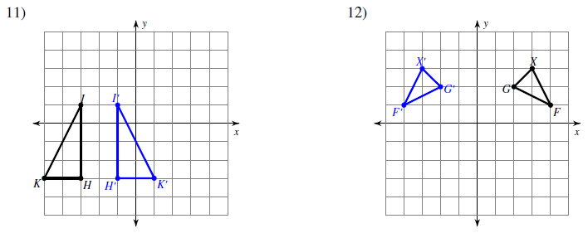
Algebraic Rule:
Description:
Description:
13) 14)
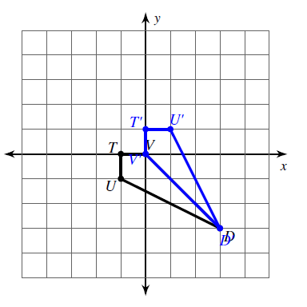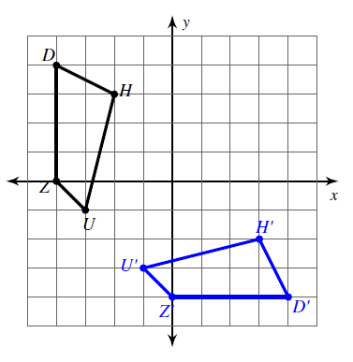
Algebraic Rule:
Algebraic Rule:
Description:
Description:

