**Rotations with Coordinates**

**Warm-Up**: Given triangle ABC with A(-1, 4), B(4, 3) and C(1, -5), graph the image points after the following transformations, identify the coordinates of the image, and write the Algebraic Rule for each.

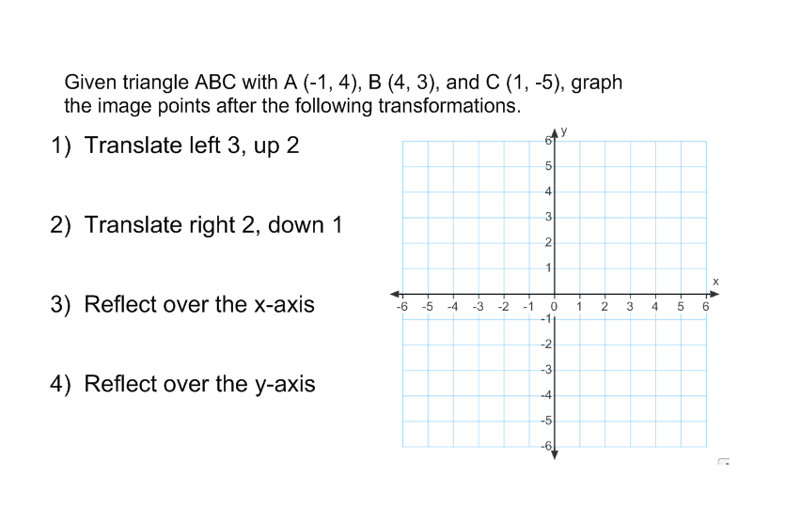

1. Translate triangle ABC left 3, up 2

Points: Algebraic Rule:

1. Translate triangle ABC right 2, down 1

Points: Algebraic Rule:

**Rotations with a Coordinate Plane and with Polygons**

**4. Visualizing Rotations Centered About the Origin**

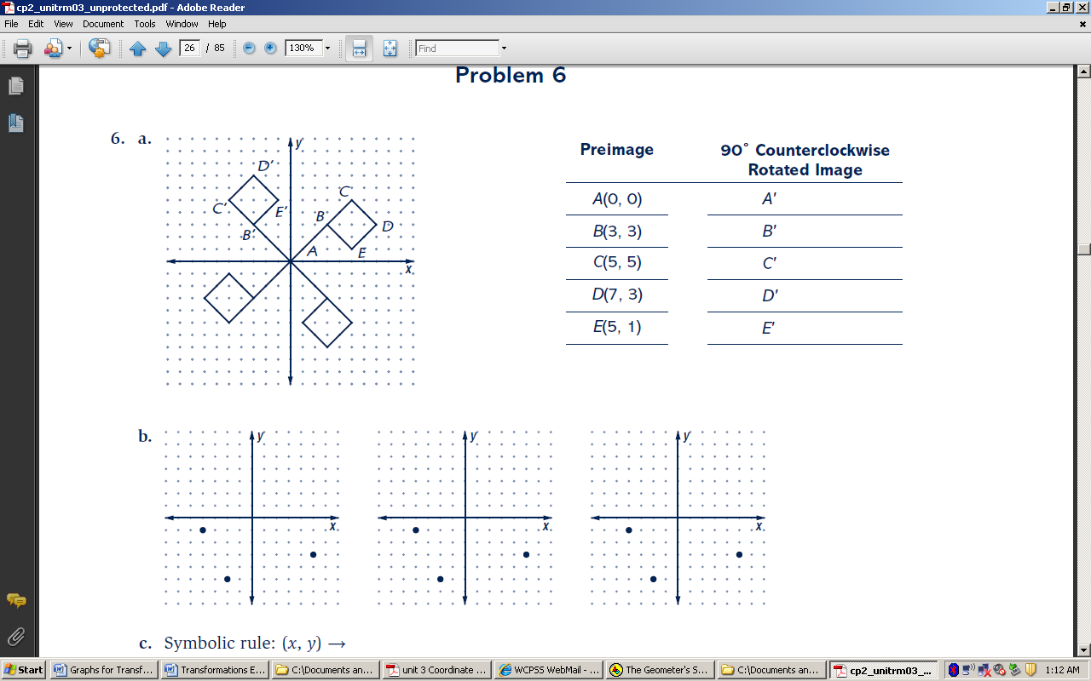The flag shown below is rotated about the origin 90°, 180°, and 270°. Flag ABCDE is the preimage. Flag A’B’C’D’E’ is a 90° counterclockwise rotation of ABCDE.

________ - __________

___________ Degrees!

______________

_____________ Degrees!

**NOTE:** Unless otherwise specified, the standard for rotations is **counterclockwise!**

**Notation for Rotations  
 R _________________________ , ___________________________**

**Example: R O , 90°**

1. **Rotations on the Coordinate Plane Exploration**
2. Triangle ABC has coordinates A(2, 0), B(3, 4), C(6, 4). Trace the triangle and the x- and y-axes on patty paper.
3. Rotate Triangle ABC 90°, using the axes you traced to help you line it back up. Record the new coordinates. A’( _____ , _____ ), B’( _____ , _____ ), C’( _____ , _____ )
4. Rotate Triangle ABC 270°, using the axes you traced to help you line it up. Record the new coordinates. A’( _____ , _____ ), B’( _____ , _____ ), C’( _____ , _____ )
5. Rotate Triangle ABC 180°, using the axes you traced to help you line it back up correctly. Record the new coordinates. A’( _____ , _____ ), B’( _____ , _____ ), C’( _____ , _____ )

**Checkpoint: Look at the patterns and complete the rule. Then write the rule using proper notation for 1 – 3.**

1. A 90° counter-clockwise rotation maps (x, y) → ( _______, _______ ). Notation: __________
2. A 270° counter-clockwise rotation maps (x, y) → ( _______, _______ ). Notation: __________
3. A 180° rotation maps (x, y) → ( _______, _______ ). Notation: __________
4. A rotation of 270° clockwise is equivalent to a rotation of ______________________________.
5. A rotation of 270° counterclockwise is equivalent to a rotation of _________________________.