**Day 2: Introduction to Transformations and Translations**

**Warm-Up**:

**1.**

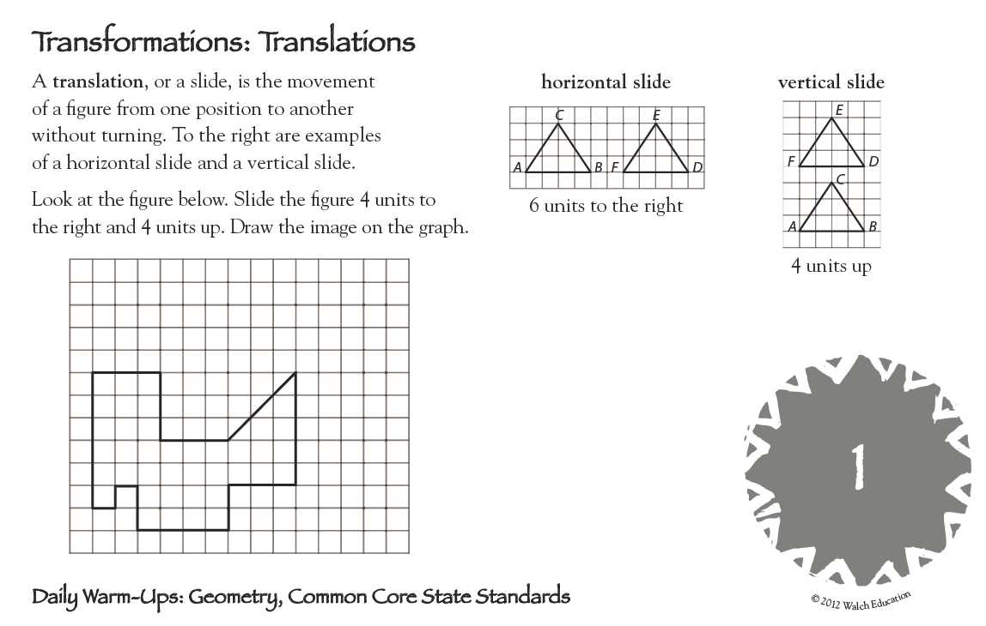

**Introduction to Transformations and Translations**

**Congruent figures** _______________________________________________________________ .

When two figures are congruent, you can move one so that ____________________________

_______________________________________________.

**Transformation** of a geometric figure: change in its ______________, ____________, or ________.

**Preimage** – ________________ figure

Notation: __________

**Image** – _______ or _______________ figure

Notation: __________



**Isometry** – transformation in which preimage and image are the ____________ _____________ and

_______________ (also called: ______________________________________________)



Examples:

___________________ , _____________________ , and __________________

**Translation** – an isometry that maps all points the ___________ _____________________ and the

___________ ___________________.

**Translation Vector** – an arrow that indicates the **distance** and **direction** to translate a figure in a plane.   
  in the activity above is an example of a translation vector.

The notation for a vector is: < -*a, b* > for a translation *a* units to the left and *b* units up.

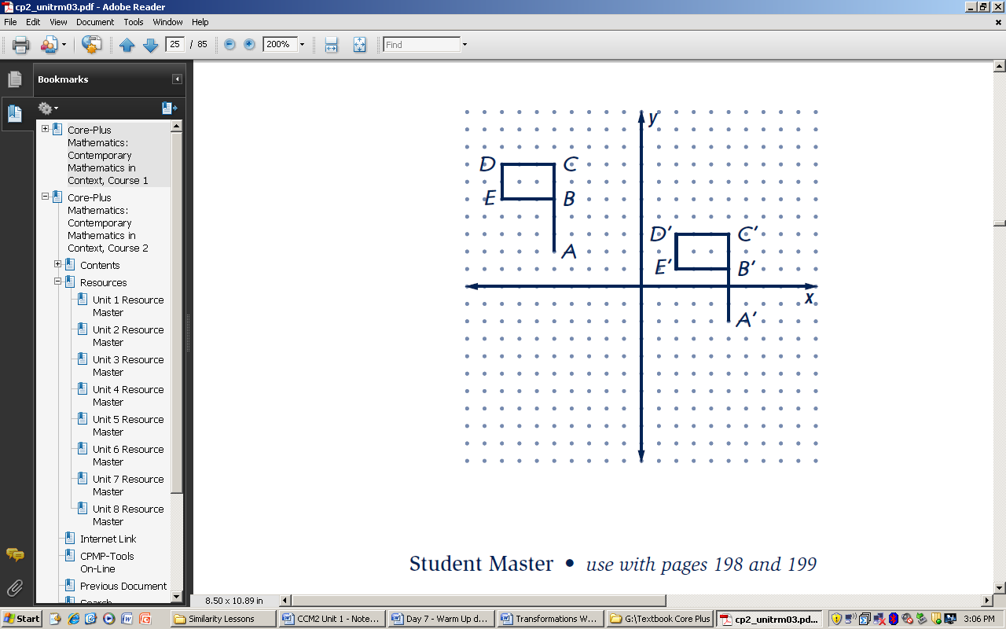

**Three ways to describe a transformation** (using example shown right):

**Always **be specific** when completing **any** type of description!!

1. **Words:** Translation to the right 10 units and down 4 units.
2. **Algebraic** **rule** (motion rule): T: (x, y) -> (x + 10, y – 4)
3. **Vector:** < 10, - 4 >

**Activity: Dot Paper Translations**

1. Use the dots to help you draw the image of the first figure so that A maps to A’.
2. Use the dots to help you draw the image of the second figure so that B maps to B’.
3. Use the dots to help you draw the image of the third figure so that C maps to C’.
4. Complete each of the following translation rules using your mappings from 1 – 3 above.
5. For A, the translation rule is: T:(x, y) → ( _______, _______ ) or <_____, _____>
6. For B, the translation rule is: T:(x, y) → ( _______, _______ ) or <_____, _____>
7. For C, the translation rule is: T:(x, y) → ( _______, _______ ) or <_____, _____>

**. . . . . . . . . . . . . .**

**. . . . . . . . . . . . . .**

B’

**. . . . . . . . . . . . . .**

**. . . . . . . . . . . . . .**

**. . . . . . . . . . . . . .**

B

A

**. . . . . . . . . . . . . .**

**. . . . . . . . . . . . . .**

**. . . . . . . . . . . . . .**

**. . . . . . . . . . . . . .**

C

A’

**. . . . . . . . . . . . . .**

**. . . . . . . . . . . . . .**

**. . . . . . . . . . . . . .**

C’

**. . . . . . . . . . . . . .**

**. . . . . . . . . . . . . .**

**. . . . . . . . . . . . . .**

**Checkpoint:** ΔGEO has coordinates G(-2, 5), E(-4, 1) O(0, -2). A translation maps G to G’ (3, 1).

1. Find the coordinates of: a) E’ ( _____, _____) b) O’ ( _____, _____)
2. The translation rule is T: (x, y) → ( _______, _______ )
3. The vector is <_____, _____>
4. Specifically describe the transformation: ________________________________________

**Reflections**

**Reflection Exploration**

1. ΔABC and ΔXYZ are reflections of each other. While holding the paper towards the light, fold the paper so that the triangles coincide (line up on top of each other). Crease the fold. Then open your paper back up and trace over this fold line using a straightedge to keep it neat.
2. Using a straightedge, draw , , and . Look at each segment in relationship to the reflection line. What appears to be true about the reflection line? Discuss lengths of segments and angles created in relationship to the reflection line.

**Mira Reflections**

Use a Mira to reflect each figure across the dashed line. Label the image points with proper notation.

|  |  |
| --- | --- |
|  |  |

3) Points A and B are on the line of reflection. How are A’ and B’ related to the reflection line?

1. Using a straightedge, draw CC ’. How is the reflection line related to CC ’?

**Checkpoint: Reflections:**

* A reflection is a transformation in which the image is a mirror image of the preimage.
* A point on the line of reflection maps to ______________________ .
* Other points map to the _________________________ side of the reflection line so that the   
   reflection line is the _______________________ of the segment joining a preimage and image point.
* Preimage and image points are equidistant from the ___________________ line.
* Notation for reflections is R line of reflection  . Example: R x-axis means reflection across the x-axis.

**Activity: Reflections in the coordinate plane.** Given ∆REF: R(-3, 1), E(0, 4), F(2, -5)

1. On the first grid, draw the reflection of ∆REF in the x-axis. Notation: R x-axis

Record the new coordinates: R’( _____ , _____ ), E’( _____ , _____ ), F’( _____ , _____ )

1. On the second grid, draw the reflection of ∆REF in the y-axis. Notation: __________

Record the new coordinates: R’( _____ , _____ ), E’( _____ , _____ ), F’( _____ , _____ )

 

1. Graph the line y = x on the third coordinate grid. Trace ∆REF, both axes, and the line y = x on patty paper. Then flip the patty paper over and line it up again to see where the triangle’s image would be if you reflected it in the line y = x. Record the new coordinates: R’( ___ , ___ ), E’( ___ , ___ ), F’( ___ , ___ )
2. Graph the line y = -x on the fourth coordinate grid. Trace ∆REF, both axes, and the line y = -x on patty paper. Then flip the patty paper over and line it up again to see where the triangle’s image would be if you reflected it in the line y = -x. Record the new coordinates: R’( ___ , ___ ), E’( ___ , ___ ), F’( ___ , ___ )

 

**Checkpoint: Look at the patterns and complete the rule. Then write the rule using proper notation.**

1. Reflection in the x-axis maps (x, y) → ( _______, _______ ) Notation: ____________
2. Reflection in the y-axis maps (x, y) → ( _______, _______ ) Notation: ____________
3. Reflection in the line y = x maps (x, y) → ( _______, _______ ) Notation: ____________
4. Reflection in the line y = -x maps (x, y) → ( _______, _______ ) Notation: ____________