Day 2 Homework
Graph the image of the figure using the transformation given write the algebraic rule and as requested write a specific verbal description or vector.
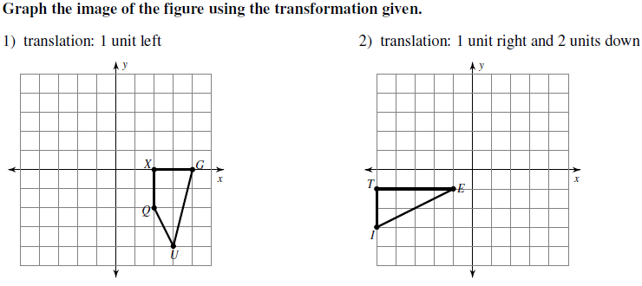
translation: < 1, -2 >
Algebraic Rule:

Vector:
Algebraic Rule:

Vector:
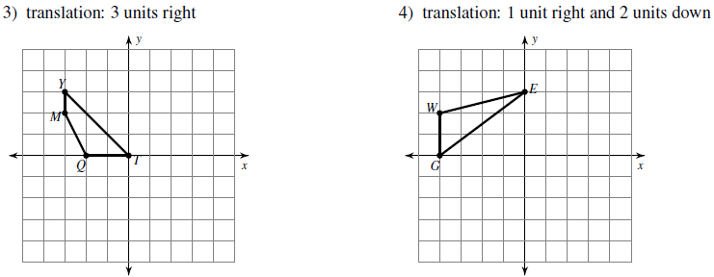

Algebraic Rule:

Description:
Algebraic Rule:

Vector:
translation: < 0, 3 >
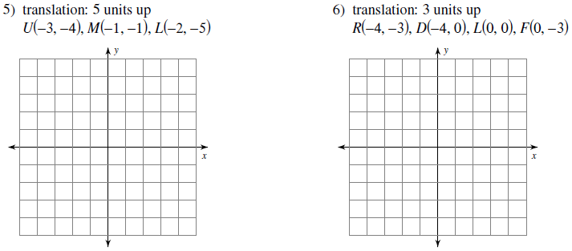
Algebraic Rule:

Description:
Algebraic Rule:

Vector:
Find the coordinates of the vertices of each figure after the given transformation and write the algebraic rule.
7) Translation: 2 units left and 1 unit down 8) Translation: 2 units down
Q(0, -1), D(-2, 2), V(2, 4), J(3, 0) D(-4, 1), A(-2, 5), S(-1, 4), N(-1, 2)
Vertices:
Algebraic Rule:
Vertices:
Algebraic Rule:

9) Translation: < -4, 4 > 10) Translation: 3 units right and 4 units up
J(-1, -2), A(-1, 0), N(3, -3) Z(-4, -3), I(-2, -2), V(-2, -4)
Vertices:
Algebraic Rule:
Vertices:
Algebraic Rule:

Write a specific description of each transformation and give the algebraic rule.
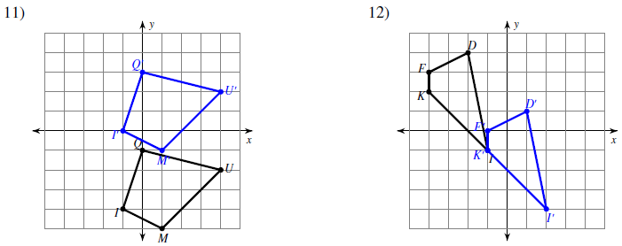
Description:

Algebraic Rule:
Description:

Algebraic Rule:
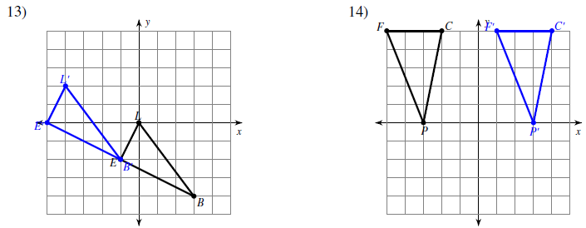
Description:

Algebraic Rule:
Description:

Algebraic Rule:

