**Honors Math 2**

**Congruent Triangles Homework**

I. Name the congruent triangles.

1. $∆OGD≅∆_________$ 2. ___________

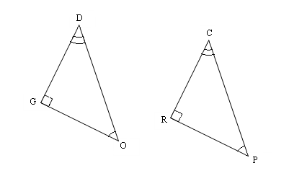

**C**

**O**

**G**

**R**

**A**

**E**

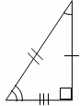3. $∆LIN≅∆$_______ 4. $∆FOX≅∆$

_______

A

I

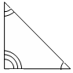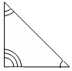

B

O

X

F

O

X

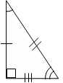

E

L

N P

Use the congruency statement to fill in the corresponding congruent parts.

5.   

  

6. . Find x. 7. Find y.

R

Q

N

M

P

x°

A

B

C

D

3y

21

35o

For each pair of triangles, tell which postulates, **if any**, make the triangles congruent.

8. ΔABC ≅ ΔEFD ______________ 9. ΔABC ≅ ΔCDA ______________

C

A

D

B

C

A

B

D

F

E

10. ΔABC ≅ ΔEFD ______________ 11. ΔADC ≅ ΔBDC ______________

A

B

D

C

A

C

B

D

F

E

For each pair of triangles, tell: (a) Are they congruent (b) Write the triangle congruency statement. (c) Give the postulate that makes them congruent.

12. 13. 14. Given: T is the midpoint of WR

L

O

V

E

E

A

A

B

D

E

C

T

R

W

a. ______________ a. ______________ a. ______________

b. Δ_____ ≅ Δ _____ b. Δ_____ ≅ Δ _____ b. Δ_____ ≅ Δ _____

c. ______________ c. ______________ c. ______________

Using the given postulate, tell which parts of the pair of triangles should be shown congruent.

15. SAS 16. ASA 17. SSS

A

B

C

D

C

A

B

D

E

F

F

A

D

E

B

C

_______ ≅ ________ ________ ≅ ________ _______ ≅ _______