Honors Math 2

* **Congruent figures:** Figures that have the same _____________ and ___________.
* When two figures are congruent, you can move one so that it fits exactly on the other. Three ways to make such a move are: a slide, a flip, and a turn.

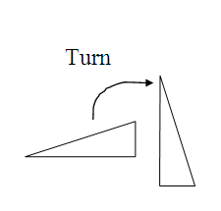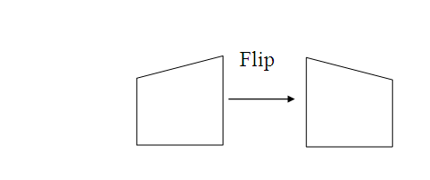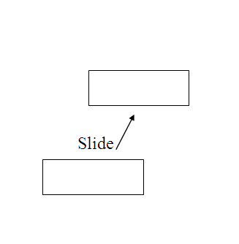

* **Congruent Polygons**: Polygons that have **________________ _________________ __________**

(their matching sides and angles). Matching vertices are corresponding vertices.

* When you name congruent polygons, you should always list corresponding vertices in the same order.

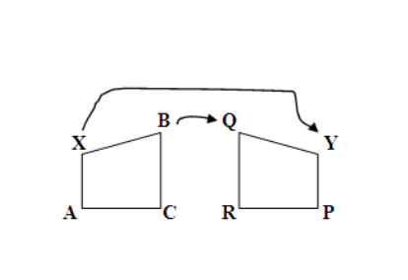

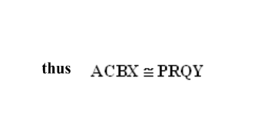**Correspondence Notation**: ACBX PRQY

Name the corresponding parts in exs 1 & 2.

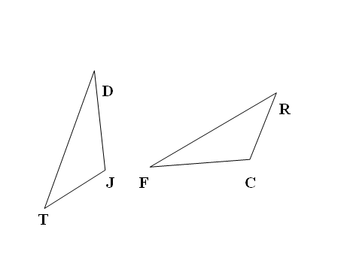

1. 

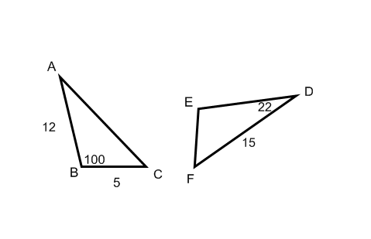2. 

3. Find the missing angles and sides if .

4. Given: . If m∠Y = 35°, what is m∠K? _________ Why?

5. Are the triangles below congruent? Explain your answer.

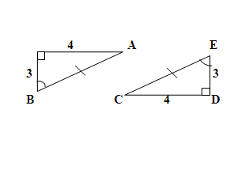

5. Are the triangles below congruent? Explain.

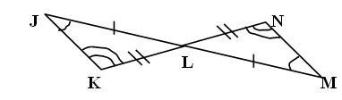

**Theorem**: If two angles of one triangle are congruent to two angles of another   
 triangle, then the third angles are congruent.

**Ways to Prove Triangles Congruent**

* 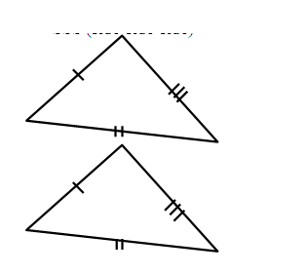**Side-Side-Side Postulate**: If 3 sides of one triangle are congruent to 3 sides of another triangle, then the triangles are congruent. (SSS)
* 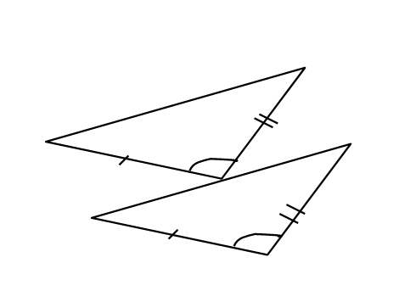**Side-Angle-Side Postulate**: If 2 sides and the included angle of one triangle are congruent to 2 sides and the included angle of another triangle, then the triangles are congruent. (SAS)
* 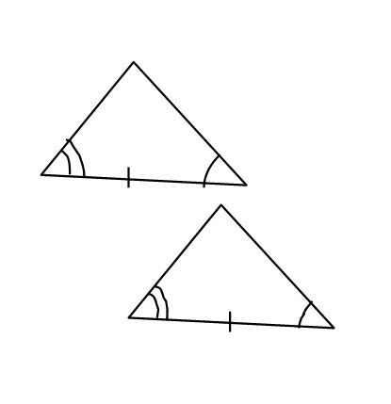**Angle-Side-Angle Postulate**: If 2 angles and the included side of one triangle are congruent to two angles and the included side of anther triangle, then the triangles are congruent. (ASA)
* **Angle-Angle-Side Theorem**: If two angles and the non-included side of one triangle are

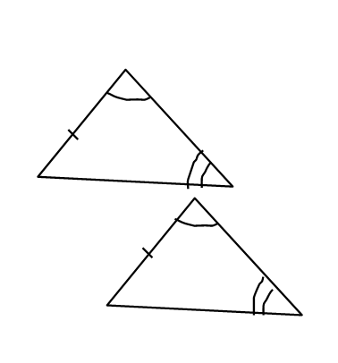congruent to two angles and the non-included side of another triangle, then the triangles are congruent. (AAS)

**Notice how ASA and AAS are different:

Do not confuse SAS with SSA. There is not an SSA reason to prove triangles congruent.

*(use triangle to the right for #1 & 2)*

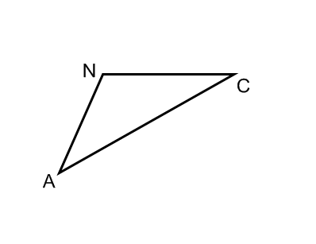 1. Which angle is included between ?

2. Which side is included between ∠C and ∠N?

*(no picture drawn for #3 & 4)*

3. Which side is included between ∠X and ∠Z in ?

4. Which angle is included between *XY* and *XZ* in *XYZ* ?

5. What additional information would you need to 6. Given: 

prove the following two triangles congruent by SAS? Is the information enough to prove

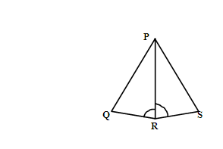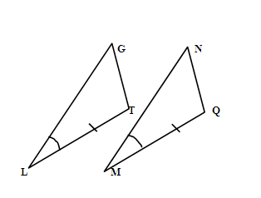 ?

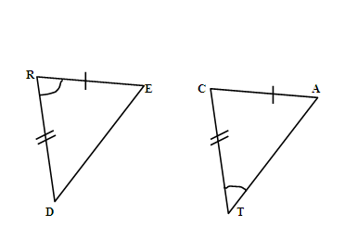 a) b)

9. Write the congruence statement for the two triangles you can prove congruent by the ASA Postulate.

