**Compositions & Glide Reflections**

**Example 1**:

Reflect  about the x-axis and then

about the line y = -1. What other transformation

could accomplish the same end result?

**Example 2**:

Reflect  about the

line y = x and then about the line x = 0.

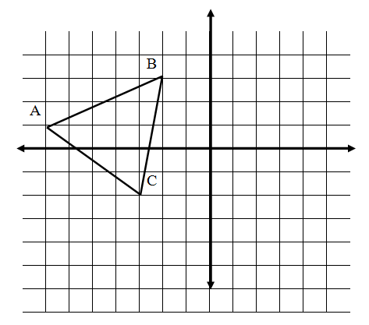

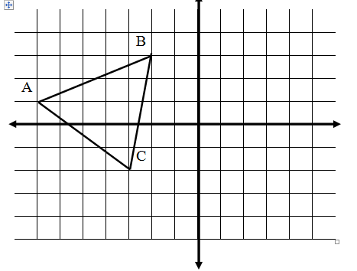

**Theorem:** A composition of reflections in two parallel lines is a translation

Reflect over line n, then reflect over line m.

**L**

Measure the distance from the preimage to the final image.

Measure the distance from line n to line m.

n

m

What can you conclude about consecutive reflections over parallel lines?

**Theorem:** A composition of two reflections in two intersecting lines is a rotation

Reflect over line m, then reflect over line l.

Measure the acute angle formed by line l and line m.

Measure the angle of rotation (from the preimage to the final image)

What can you conclude about consecutive reflections over intersecting lines?

**Examples**

1. Two lines intersect at a 50 $°$ angle. Write the composition of two reflections over the lines as a  
 single transformation.

2. Two parallel lines are 3 cm apart. Describe the composition of two reflections over the lines as a  
 single transformation.

3. A figure is reflected over the y-axis and then reflected over the line y = x. Write as a single  
 transformation.

**Compositions**

Translation R maps P to P’ and translation S maps P’ into P”. Find T, the translation that maps **P directly to P”.**

1. R: (x, y) (x – 3, y + 2) 2. R: (x, y)  (x, y + 1)

S: (x, y)  (x + 1, y + 7) S: (x, y)  (x + 4, y - 1)

T: (x, y)  ( , ) T: (x, y)  ( , )

3. R: (x, y)  (x + 1, y - 3)

S: (x, y)  (x - 4, y - 3)

T: (x, y)  ( , )

**More Practice**

4. The translation T is followed by the translation T.   
 Write this as a single translation.

5. The rotation ${\text{R}}_{O, 90°}$ is followed by the rotation ${\text{R}}_{O, -270°}$. Write this as a single rotation.

6. The reflection $R_{x-axis}$ is followed by the reflection $R_{y-axis}$. Can this be written as a single reflection?

Can this be written as a single transformation? Draw a sketch to support your answer.

**Glide Reflection:** the composition of 3 reflections in lines that intersect in more than one point

[can also be written as a translation (glide) followed by a reflection]

A glide reflection changes orientation. Why?

**Theorem:** there are only 4 isometries

* Reflection
* Translation
* Rotation
* Glide reflection

**Glide Reflection:**

7. A glide reflection has the glide (translation) T: (x, y)  (x – 2, y – 2).

Its line of reflection is y = x

a.) Find the image P’ of P(3, 5) under T.

b.) Find the image P” of P’ under the reflection in line y = x.

c.) Under the glide reflection, (x, y) is mapped into (?, ?) and then into (?, ?)

A glide reflection has translation T and reflection in the given line.

a.) Find the image P’ of P under T

b.) Find the image P” of P’ under reflection in the line

c.) Under the glide reflection, (x, y) is mapped to (?, ?) and then to (?, ?)

8. T: (x, y) (x + 4, y + 4) 9. T: (x, y)  (x, y - 2)

Reflection line is: y = x Reflection line is: y-axis

P (4, 0) P (-1, 5)

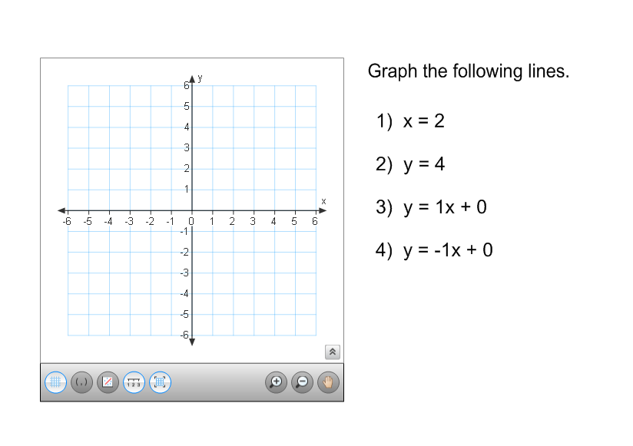

****10. T: (x, y)  (x , y +1)

Reflection line is: x-axis

P (2, 3)

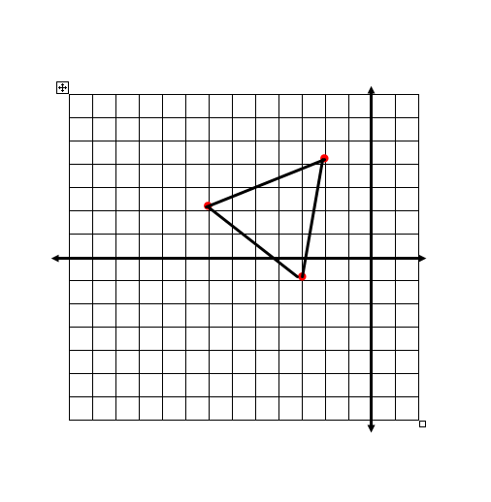11. In each exercise below, a glide reflection is described. Graph  and its image under the glide,. Also graph , the image of  under the reflection. Use different colored pencils.

A.) Given: A (-3, -1), B (-2, 4), and C (-7,2)

Glide: (x, y)  (x + 3, y)

Reflection line: the x-axis

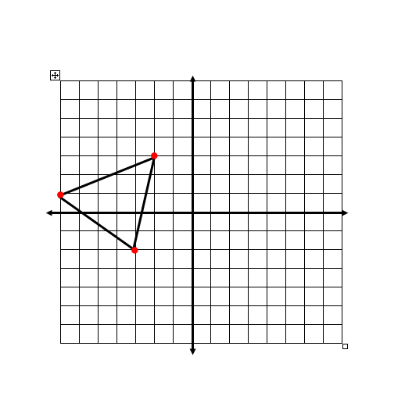

B.) Given: A (-3, -2), B (-2, 3), and C (-7,1)

Glide (x, y) (x, y – 5)

Reflection line: the y-axis